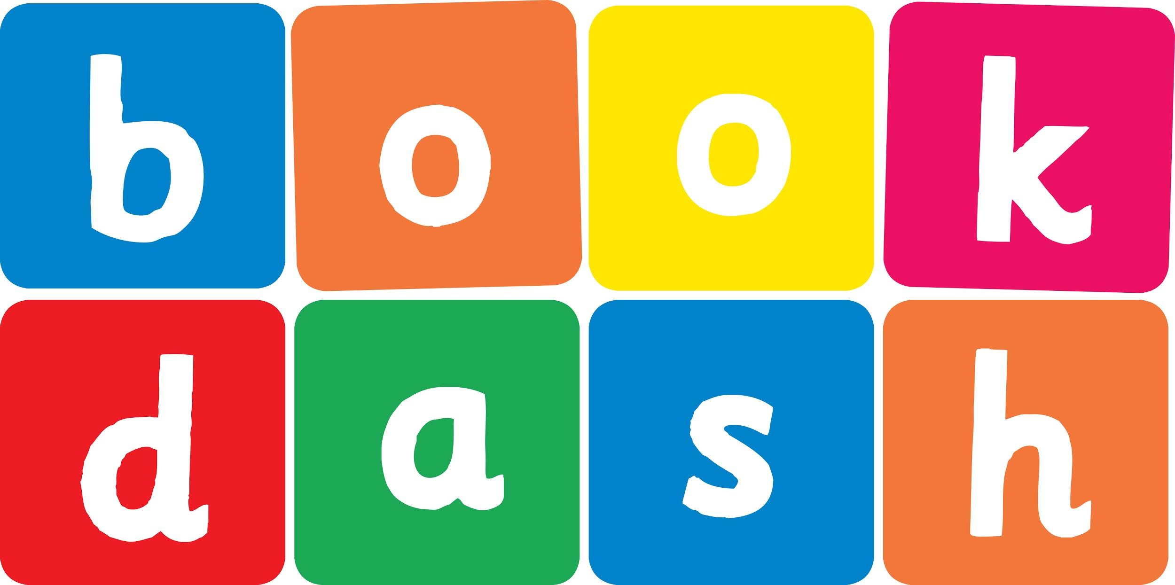
Book Dash Translation Template

Instructions
- If no text appears on a page, please indicate this in the cell with “N/A”
- Please save this file using the format: english-title_language.doc. For example: singing-the-truth_isixhosa.doc

Book Title in English: | Egg
Language of Translation: | Afrikaans
Translated Title: | Eier
Translator’s full name and/or organisation: | Dorette Louw

Page | English | Translation
Cover | Egg | Eier
Inside front cover | Blank | Blank
1 Book-plate page. | Egg  This book belongs to | Eier  Hierdie boek behoort aan
2 Endpapers. | No text | NA
3 Endpapers. | No text | NA
4 Copyright page. No need to translate. | No translation | NA
5 Title page. | Egg | Eier
6 | Egg | Eier
7
8 | My egg? | My eier?
9
10 | Not my egg. | Nie my eier nie.
11
12 | My egg? | My eier?
13
14 | Not my egg. | Nie my eier nie.
15
16 | My egg? | My eier?
17
18 | Not my egg. | Nie my eier nie.
19
20 | My egg? | My eier?
21
22 | Not my egg. | Nie my eier nie.
23
24
25 | My egg. | My eier.
26
27 | Our egg. | Ons eier.
28 Endpapers. | No text | NA
29 Endpapers. | No text | NA
30 Blank or decoration. | No translation unless there is text
Inside back cover. | No text | NA
Back cover | Crocodile, Tortoise, Penguin and Chicken find an egg. Is it their egg?  ‘Our egg,’ say the proud mum and dad at the end.  Discover whose egg it is. | Krokodil, Skilpad, Pikkewyn en Hoender vind ‘n eier. Is dit hul eier?  “‘Ons eier,” sê die trotse mamma en pappa aan die einde.  Vind uit wie se eier dit is.

