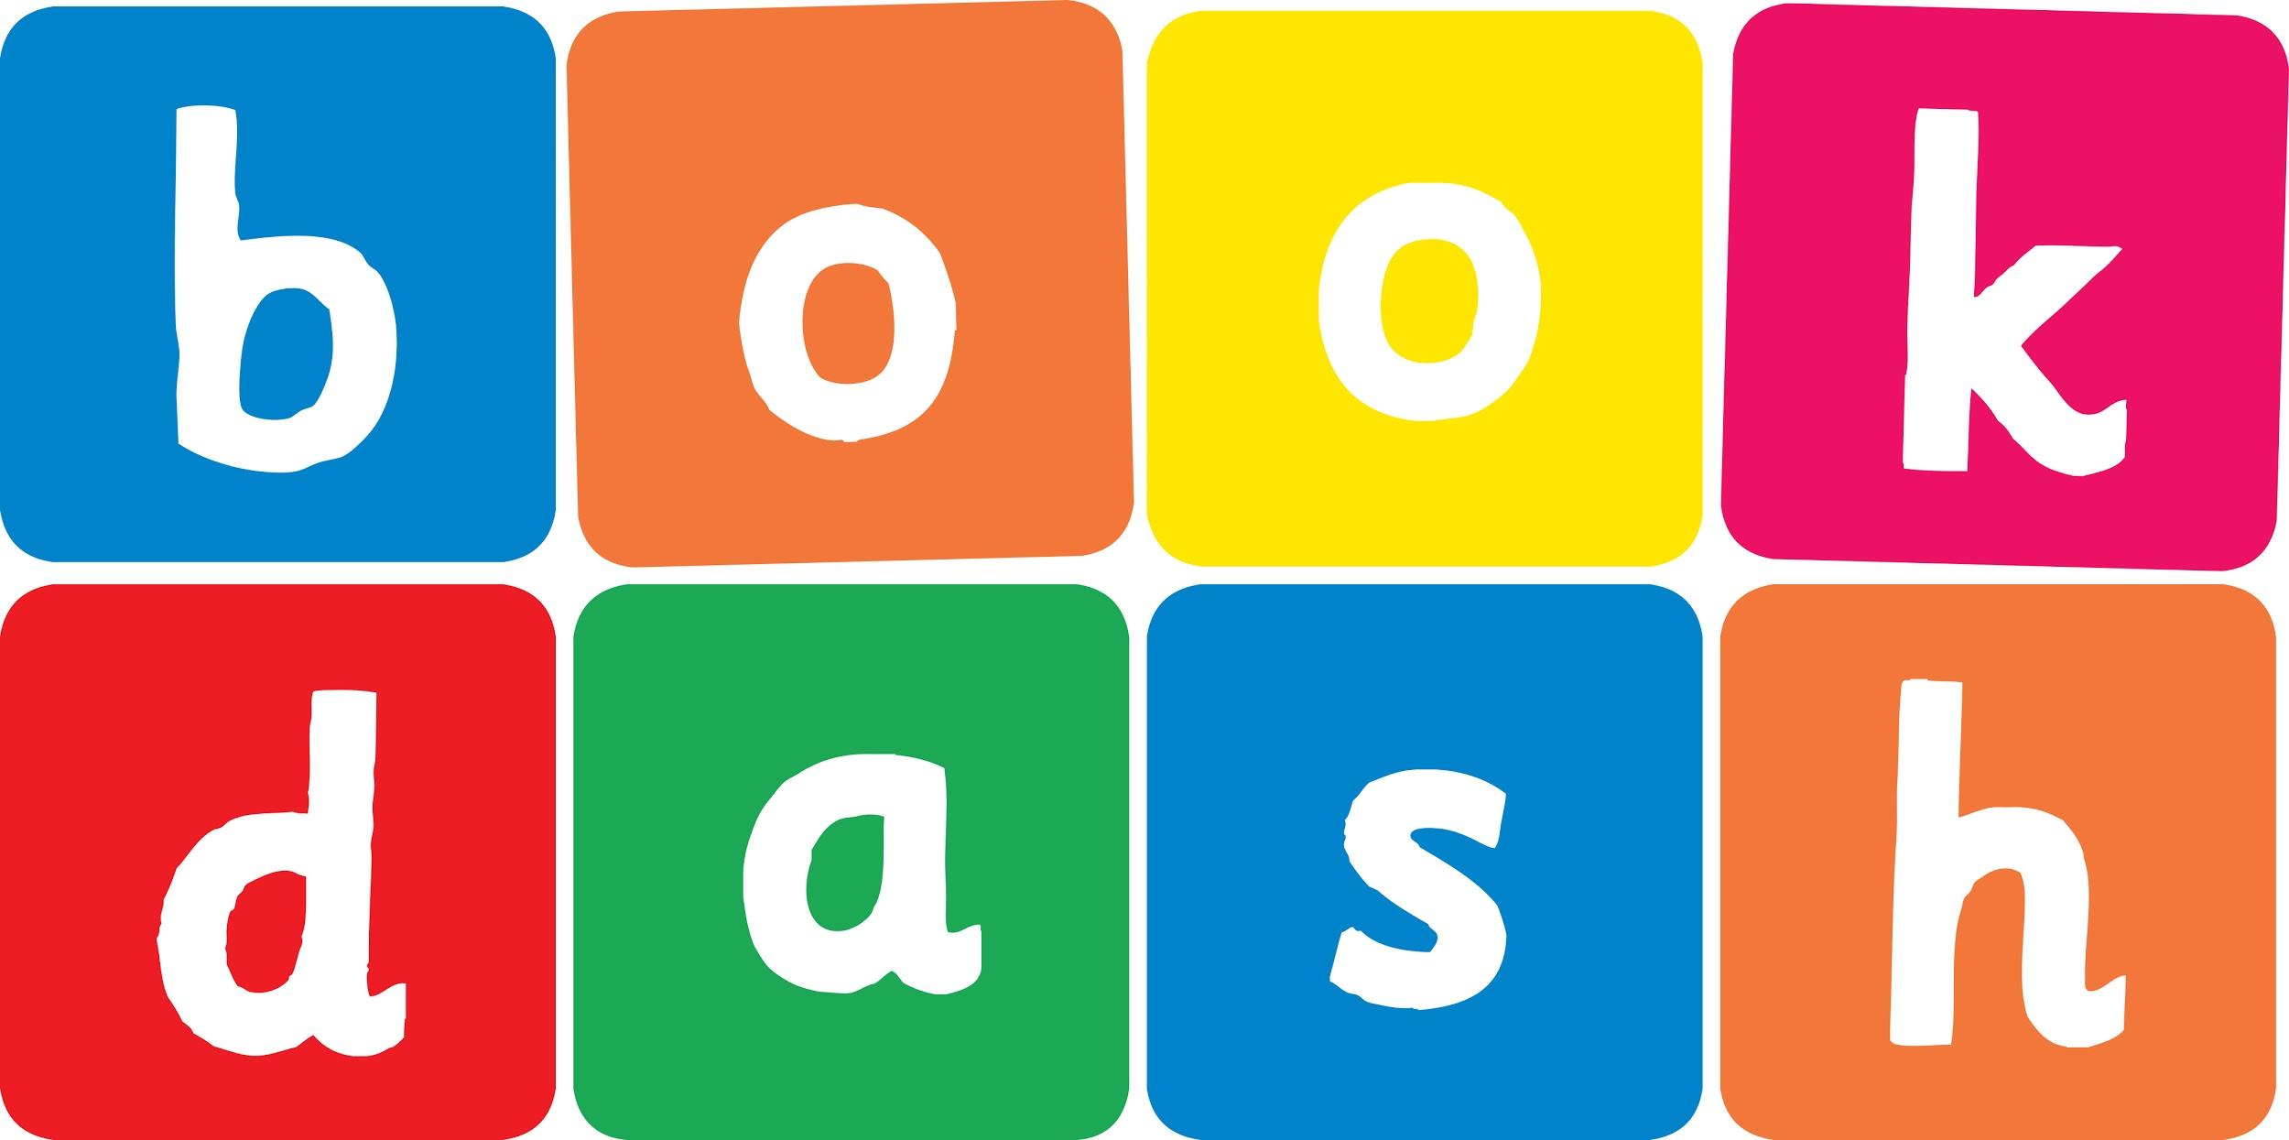
Book Dash Translation Template

Instructions
- If no text appears on a page, please indicate this in the cell with “N/A”
- Please save this file using the format: english-title_language.doc. For example: singing-the-truth_isixhosa.doc

Book Title in English: | I want to!
Language of Translation: | IsiXhosa
Translated Title: | Ndifuna!
Translator’s full name and/or organisation: | Sihle Siko

Page | English | Translation
Cover | Title | I want to!
Inside front cover | No text | NA
Book-plate page. | I want to!  This book belongs to | Ndifuna!  Le ncwadi yeka
Endpapers. | No text | NA
Endpapers. | No text | NA
Copyright page. No need to translate. | No translation | NA
Title page. | I want to! | Ndifuna!
1 (leave blank if no text) | I want to crawl | Ndifuna ukugaqa
2 | I want to climb | Ndifuna ukugwencela
3 | I want to eat | Ndifuna ukutya
4 | I want to drink | Ndifuna ukusela
5 | I want to sing | Ndifuna ukucula
6 | I want to play | Ndifuna ukudlala
7 | I want to draw | Ndifuna ukuzoba
8 | I want to splash | Ndifuna ukuqubha
9 | I want to go to Mama | Ndifuna ukuya kuMama
10 | I want to read | Ndifuna ukufunda
11 | I want to hug | Ndifuna ukwanga
12 | I want to sleep | Ndifuna ukulala
13
14
15
16
17
18
19
20
21
22
23
24
Endpapers. | No text | NA
Endpapers. | No text | NA
Blank or decoration. | No translation unless there is text
Inside back cover. | No text | NA
Back cover | This cute little baby knows exactly what she wants. She wants to eat, she wants to play, and she wants to read a book with Mama! | Lo bhabha mncinci mhle uyazi ncam into ayifunayo. Ufuna ukutya, ufuna ukudlala, yaye ufuna ukufunda incwadi noMama!

