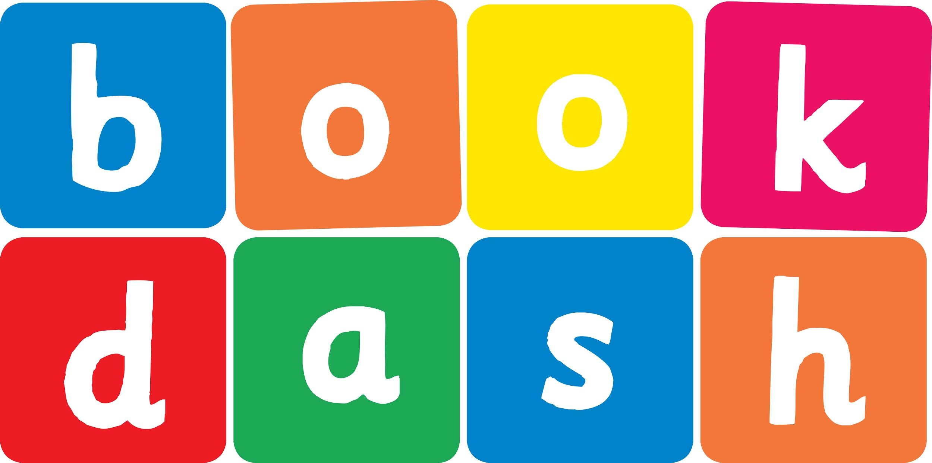
Book Dash Translation Template

Instructions
- If no text appears on a page, please indicate this in the cell with “N/A”
- Please save this file using the format: english-title_language.doc. For example: singing-the-truth_isixhosa.doc

Book Title in English: | I’m the colour of honey
Language of Translation: | isiZulu
Translated Title: | Ngingumbala woju
Translator’s full name and/or organisation: | Nonkululeko Nhlapo

Page | English | Translation
Cover | Title | Ngingumbala woju
Inside front cover | No text | NA
Book-plate page. | Title  This book belongs to: | Ngingumbala woju  Le ncwadi ngeka
Endpapers. | No text | NA
Endpapers. | No text | NA
Copyright page. No need to translate. | No translation | NA
Title page. | Title
1 (leave blank if no text)
2
3
4
5 | I ’ m t h e  c o l o u r o f honey | Ngingumbala woju
6
7 | My name is Amanda. I live with my Mummy, my Daddy and my dog Porsha. My Daddy says I’m the colour of honey. My Mummy says I look like a beautiful sunset. | Igama lami ngingu-Amanda. Ngihlala nomama nobaba wami kanye nenja yami uPorsha. Ubaba wami uthi ngingumbala woju. Umama yena uthi ngimuhle kuhle kwelanga liyoshona.
8
9 | But I don’t look like either of them. Only Porsha is brown like me! | Kodwa angifani nabo bobabili. UPhorsha nje kuphela unombala omdaka njengami!
10
11 | When we go out some people stare at us, or ask us lots of questions. | Uma sizikhiphile abantu bavame ukusibuka, noma babuze imibuzo eminingi.
12 | “Is that your Aunty?” asks the woman at the store. | “Ubabekazi wakho lowo?” kubuza owesimame esitolo.
13 | “No! It’s my mummy.” | “Cha! Umama wami.”
14 | “Is that your Teacher?” asks the man in the park. | “Ngabe uthisha wakho?” kubuza owesilisa epaki.
15 | “No! It’s my daddy.” | “Cha! Ubaba wami.”
16 | “Why don’t you look like them?”  “Because I’m the colour of honey. And I look like a beautiful sunset.” | “Kungani ungafani nabo?”  “Yingoba ngingumbala woju. Futhi ngimuhle kuhle kwelanga liyoshona.”
17
18
19 | “But your Daddy is like a night sky,” says the woman at the store.  “And your Mummy is as white as the blank pages in a book,” says the man in the park. | “Kodwa ubaba wakho ngathi isibhakabhaka ebusuku,” kusho lo wesimame esitolo.  “Kanti umama wakho umhlophe kuhle kwephepha elingabhaliwe,” kusho owesilisa epaki.
20 | “Why do you look so different?” | “Kungani wena uhlukile?”
21
22
23 | The next day I wrap a towel on my head and swing it around just like Mummy does with her hair.  “Is that your Aunty?” asks the woman at the store.  “No, that’s my Mummy!” | Ngosuku olulandelayo ngathwala ithawula ekhanda, ngaligoqa kahle njengoba umama ahlale enza ngezinwele zakhe.  “Ubabekazi wakho lowo?” kubuza owesimame esitolo.  “Cha! Umama wami.”
24 | I run home and get some black paint. I smear it on my face. | Ngigijime ngaya ekhaya ngathola upende omnyama. Ngawubhixa ebusweni bami.
25 | “Nice face painting!” says the man in the park. He points to Dad and asks, “Is that your teacher?”  “No! It’s my daddy.”  My tears wash the paint away. | “Wamuhle upende ebusweni,” kusho owesilisa epaki. Ukhomba ubaba wasebuza, “Ngabe uthisha wakho?” kubuza owesilisa epaki.  “Cha! Ubaba wami.”  Izinyembezi zami zivele zawususa upende.
26 | “Why don’t I look like you, mummy and daddy?” | “Kungani ngingafani nani, mama nawe baba?
27 | “Amanda, show me that smile, that’s just like your Daddy’s.”  I don’t feel like smiling.  “Come on Amanda, look at your dimple. It’s so pretty, just like your Mummy’s!” | “Amanda, ngibonise ukumamatheka kwakho, lokhu okufana nokukababa wakho.”  Angifuni ukumamatheka.  Hawu Amanda, buka isifaca sakho, sihle, njengesikamama wakho!”
28 | Mummy and Daddy make me smile. And I make them smile too!  “Look!” I say, “My teeth are white, just like yours.”  “Yes, and your heart is red, just like ours.” | Umama nobaba bangenza ngimamatheke kanti nami ngibenza bamamatheke!  “Buka!” kusho mina, “Amazinyo ami amhlophe njengawenu.”  “Yebo, futhi inhliziyo yakho ibomvu, njengezethu.”
29
30
31
32 | How many colours are you?
Endpapers. | No text | NA
Endpapers. | No text | NA
Blank or decoration. | No translation unless there is text
Inside back cover. | No text | NA
Back cover | Back cover blurb  Is that your teacher? Is that your aunty? Amanda is fed up with these questions and wishes that she looked just like her Mummy and Daddy. But maybe they are more alike than she realises! | Ngabe uthisha wakho? Ngabe ubabekazi wakho? U-Amanda usekhathele yile mibizo futhi ufisa ngabe ufana nomama kanye nobaba wakhe. Mhlawumbe kuningi abafana ngakho kunalokhu akubonayo

