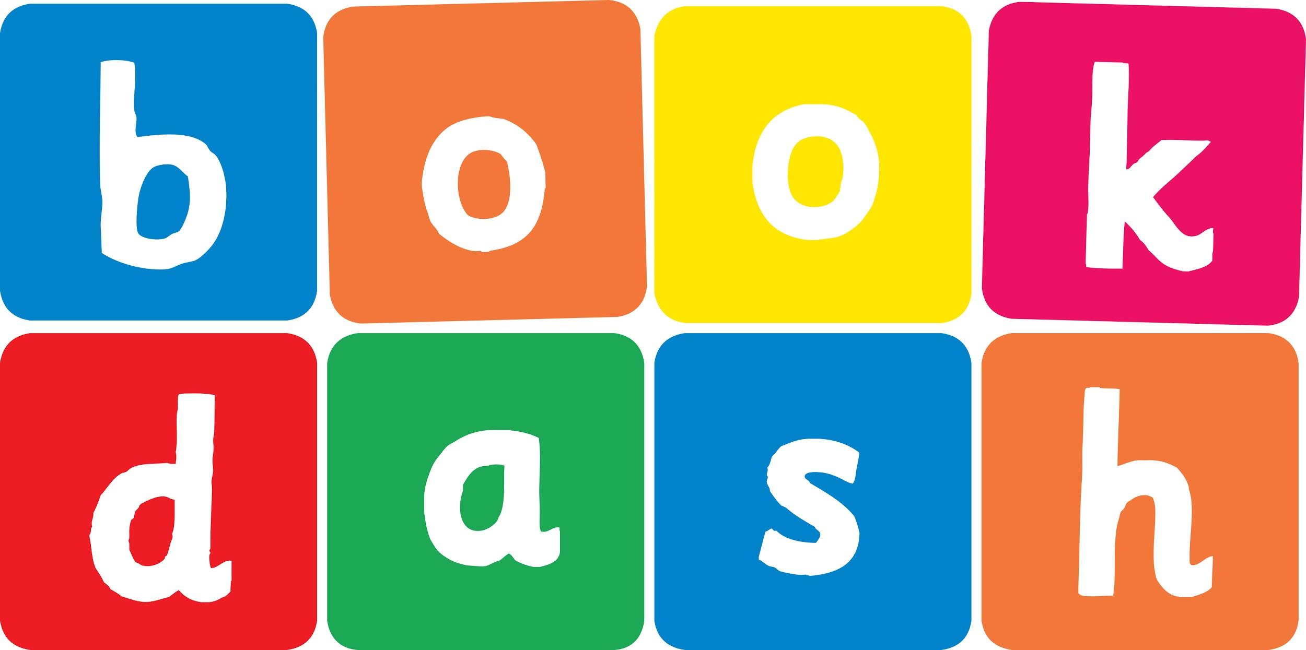
Book Dash Translation Template

Instructions
- If no text appears on a page, please indicate this in the cell with “N/A”
- Please save this file using the format: english-title_language.doc. For example: singing-the-truth_isixhosa.doc

Book Title in English: | Just Like Me
Language of Translation: | Kanye Njengam
Translated Title: | IsiXhosa
Translator’s full name and/or organisation: | Sihle Siko

Page | English | Translation
Cover | Just Like Me | Kanye Njengam
Inside front cover | No text | NA
Book-plate page. | Just Like Me  This book belongs to | Kanye Njengam  Le ncwadi yeka
Endpapers. | No text | NA
Endpapers. | No text | NA
Copyright page. No need to translate. | No translation | NA
Title page. | Just Like Me | Kanye njengam
1 (leave blank if no text)
6 | It’s Rahah’s birthday next week. She is excited about inviting her new friends to her party. | Lusuku lokuzalwa lukaRahah kwiveki ezayo. Uvuyela ukumemela abahlobo bakhe abatsha kwitheko lakhe.
7
8 | “Who will you invite?” asks Mum.  “You’ve only been at school for few months. The kids all seem so very different, don’t they?”  “No, Mum. I have few new friends,” says Rahah. | “Uza kumema bani?” uyabuza uMama.  “Uneenyanga ezimbalwa nje usesikolweni. Abantwana bonke babonakala bohlukile, abanjalo?”  “Hayi, Mama. Ndinabahlobo abambalwa abatsha,” utsho uRahah.
9
10 | “I want to invite Zerina.  She wants to be a ballerina, just like me!” | “Ndifuna ukumema uZerina.  Ufuna ukuba ngumdanisikazi webhaleyi oyintshatsheli, kanye njengam!”
11
12 | “Oh lovely,” says Mum.  “Let’s play some dance music then.” | “Kwakuhle oko,” utsho uMama.  “Masidlale umculo womdaniso ke ngoko.”
13
14
15 | “I hope that Sikelele can come too.  He sings in the school choir, just like me!” | “Ndithemba ukuba uSikelele angeza naye.  Ucula kwikwayara yesikolo, kanye njengam!”
16 | “Oh that’s good – we’ll all have fun singing too.” | “Owu kuhle oko – siza konwaba sonke sicula ngokunjalo.”
17
18
19 | “Can we invite Susheela?  She’s got fluffy kittens, just like me!” | “Singammema uSusheela?  Uneekatana ezinoboya obuthambileyo, kanye njengam!”
20 | “Yes, let’s. She will have fun playing with our kittens too.” | “Ewe, masenze njalo. Naye uza konwabela ukudlala neekatana zethu ”
21
22
23 | “And we must invite Yongnam.  She loves pink cupcakes even more than I do.” | “Yaye kufuneka simeme uYongnam.  Uthanda amaqebengwana apinki nangaphezu kwam.”
24 | “Its’s lucky I’m making cupcakes then,” says Mum.  “She can have pink ones.” | “Kungethamsanqa ndenza amaqebengwana,” utsho uMama.  “Angafumana apinki.”
25
26 | “Ah thanks, Mum! I can’t wait.”  “Oh Rahah! I am so excited to meet all your friends. They sound so special - just like you!” | “Owu enkosi, Mama! Andisangxame ngako.”  “Owu Rahah! Ndivuyela ukuba ndiza kudibana nabo bonke abahlobo bakho.  Bavakala bekhethekile – kanye njengawe!”
27
28 | “But what about you?  You love books, don’t you …  just like me!”  Would you like to come to my party too?” | “Kodwa uthini ngawe? Uyazithanda iincwadi, akunjalo … kanye njengam!”  “Ungathanda ukuza kwitheko lam nawe?”
29
30
31
32 | Thank you! | Enkosi!
Endpapers. | No text | NA
Endpapers. | No text | NA
Blank or decoration. | No translation unless there is text | N/A
Inside back cover. | No text | NA
Back cover | It’s Rahah’s birthday party.  Mum wants to know who she will invite. Will they all fit in? | Litheko lomhla wokuzalwa likaRahah.  UMama ufuna ukwazi ukuba uza kumema bani. Ingaba bonke baza kulilungela?

