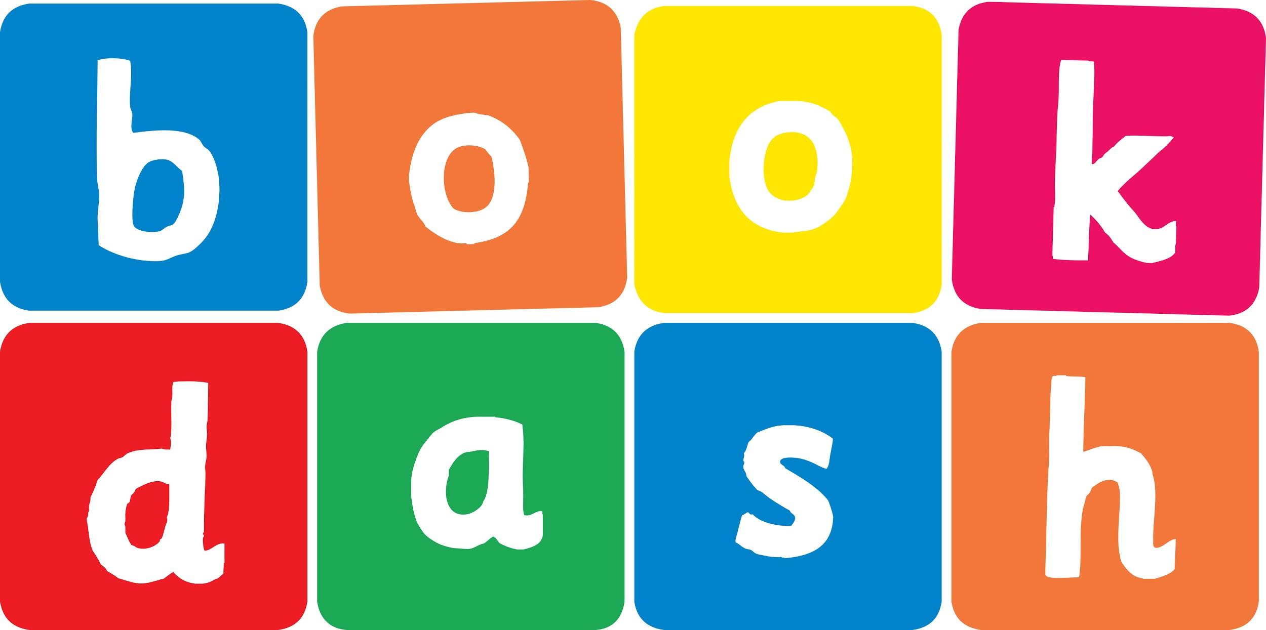
Book Dash Translation Template

Instructions
- If no text appears on a page, please indicate this in the cell with “N/A”
- Please save this file using the format: english-title_language.doc. For example: singing-the-truth_isixhosa.doc

Book Title in English: | Just Like Me
Language of Translation: | IsiZulu
Translated Title: | Njengami Nje
Translator’s full name and/or organisation: | Nonkululeko Nhlapo

Page | English | Translation
Cover | Just Like Me | Njengami Nje
Inside front cover | No text | NA
Book-plate page. | Just Like Me  This book belongs to | Njengami Nje  Le ncwadi ngeka
Endpapers. | No text | NA
Endpapers. | No text | NA
Copyright page. No need to translate. | No translation | NA
Title page. | Just Like Me | Njengami Nje
6 | It’s Rahah’s birthday next week. She’s excited about inviting her new friends to her party. | Usuku lokuzalwa lukaRahah lungesonto elizayo. Ukuthakasele ukumema abangani bakhe abasha ephathini yakhe.
7
8 | “Who will you invite?” asks Mum. “You’ve only been at school a few months. The kids all seem so very different, don’t they?”  “No, Mum. I have lots of new friends,” says Rahah. | “Uzomema bani?” kubuza uMama. “Unezinyanga ezimbalwa uqalile esikoleni esisha. Zonke izingane zibonakala zihlukile, akunjalo?”  “Cha, Mama. Nginabangani abaningi abasha,” kusho uRahah.
9
10 | “I want to invite Zerina. She wants to be a ballerina, just like me!” | “Ngifuna ukumema uZerina. Ufuna ukuba wumdansi we-ballet, njengami nje!”
11
12 | “Oh lovely,” says Mum. “Let’s play some dance music then.” | “Ohho! Kwakuhle lokho,” kusho uMama. “Asidlale umculo wokudansa uma kunjalo.”
13
14
15 | “I hope that Sikelele can come too. He sings in the school choir, just like me.” | “Ngiyathemba ukuthi uSikelele uzokwazi ukuza naye. Uculela ikwaya lesikole, njengami nje.”
16 | “Oh that’s good – we’ll all have fun singing too.” | “Ohho! kwakuhle lokho – sizojabula sonke sicule futhi.”
17
18
19 | “Can we invite Susheela? She’s got fluffy kittens, just like me.” | “Ngingamumema uSusheela? Unamakatshana amahle, njengami nje.”
20 | “Yes, let’s. She’ll have fun playing with our kittens too.” | “Yebo, ungamumema. Uzokuthokozela ukudlala namakatshana ethu naye.”
21
22
23 | “And we must invite Yongnam. She loves pink cupcakes even more than I do.” | “Futhi kumele simeme noYongnam. Uyawathanda amakhekhe aphinki ukudlula mina.”
24 | “It’s lucky I’m making cupcakes then,” says Mum.  “She can have the pink ones.” | “Yinhlanhla-ke ngoba ngenza wona lawo makhekhe,” kusho uMama. “Angawathatha lawa aphinki.”
25
26 | “Ah thanks, Mum! I can’t wait.”  “Oh Rahah! I’m so excited to meet all your friends. They sound so special just like you!” | “Ncinci ngiyabonga, Mama! Ngikulangazelele kakhulu.”  “Kuyintokozo kimi, Rahah! Ngizokuthakasela ukubona bonke abangani bakho. Bazwakala bebaluleke njengawe nje!”
27
28 | “But what about you? You love books, don’t you … just like me! Would you like to come to my party too?” | “Kodwa wena? Uyazithanda izincwadi, angithi … njengami nje! Ungathanda ukuza ephathini yami nawe?”
29
30
31
32 | Thank you! | Ngiyabonga!
Endpapers. | No text | NA
Endpapers. | No text | NA
Blank or decoration. | No translation unless there is text
Inside back cover. | No text | NA
Back cover | It’s Rahah’s birthday party. Mum wants to know who she will invite. Will they all fit in? | Iphathi yokubungaza ukuzalwa kukaRahah. UMama ufuna ukwazi ukuthi uzomema bani. Ngabe bonke bazofaneleka?

