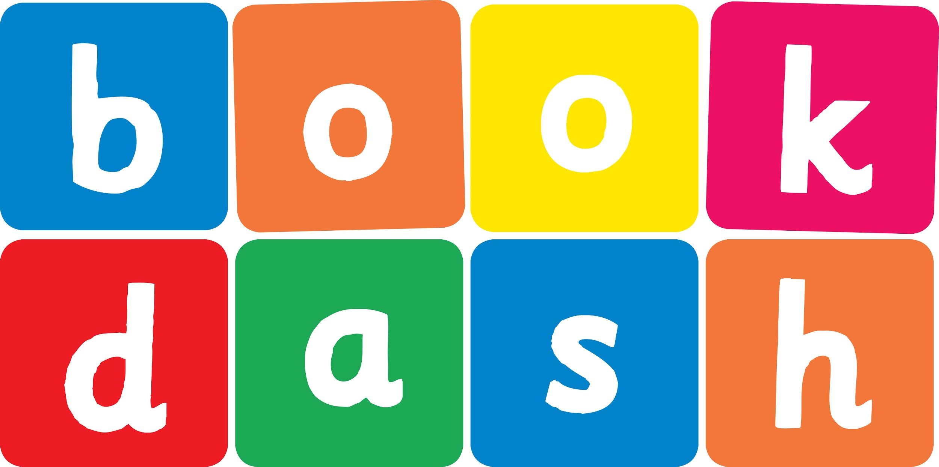
Book Dash Translation Template

Instructions
- If no text appears on a page, please indicate this in the cell with “N/A”
- Please save this file using the format: english-title_language.doc. For example: singing-the-truth_isixhosa.doc

Book Title in English: | MY SPECIAL HAIR
Language of Translation: | IsiXhosa
Translated Title: | IINWELE ZAM EZIKHETHEKILEYO
Translator’s full name and/or organisation: | Sihle Siko

Page | English | Translation
Cover | Title MY SPECIAL HAIR | IINWELE ZAM EZIKHETHEKILEYO
Inside front cover | No text | NA
Book-plate page. | MY SPECIAL HAIR  This book belongs to | IINWELE ZAM EZIKHETHEKILEYO  Le ncwadi yeka
Endpapers. | No text | NA
Endpapers. | No text | NA
Copyright page. No need to translate. | No translation | NA
Title page. | MY SPECIAL HAIR | IINWELE ZAM EZIKHETHEKILEYO
5
6 | I have a very special head, a special head of hair.  My special hair is quite unique.  My special hair is rare. | Ndinentloko ekhetheke kakhulu, intloko ekhethekileyo yeenwele.  Iinwele zam ezikhethekileyo zihlukile.  Iinwele zam ezikhethekileyo zinqabile.
7
8 | It grows not just on my head,  but mine,  my own,  just me!  My special hair does special things – it’s magic hair, you see. | Azikhuli nje entloko ,  kodwa zezam  ezam ndodwa,  mna qha!  Iinwele zam ezikhethekileyo zenza izinto ezikhethekileyo – ziinwele ezingumlingo, uyabona.
9
10
11 | In summer when the sun is hot, with no shade anywhere,  I do not sweat, I do not burn.  I grow a hat of hair. | Ehlotyeni xa ilanga litshisa, kungekho mthunzi naphi na ,  Andibili, anditshi.  Ndikhula umnqwazi weenwele.
12
13 | In winter when my nose turns red, and when the  cold  winter  blows,  my special hair grows very long.  I am wrapped from top to toes. | Ebusika xa impulo yam ijika iba bomvu,  naxa  ingqele  yobusika  ivuthuza,  iinwele zam ezikhethekileyo zikhula zibe nde kakhulu.  Zindombathisisle ukusuka phezulu ukuya ezinzwaneni.
14 | In springs when all birds come out, and each one builds a nest,  my head is full of songs because my special hair is the best. | Entwasahlobo xa zonke iintaka ziphuma, yaye iyileyo isakha indlwana,  intloko yam igcwele iingoma kuba iinwele zam ezikhethekileyo zigqwesile.
15
16 | In autumn when the leaves fall down,  no flowers to be found,  my special head begins to bloom bright blossoms all around. | Ekwindla xa kusiwa amagqabi,  kungekho zintyatyambo zifumanekayo,  intloko yam ekhethekileyo iqalisa ukudubula iintyatyambo eziqaqambileyo yonk’ indawo.
17
18 | My special hair is stiff and strong.  It does not hang or drape.  I never look the same because my hair can change its shape. | Iinwele zam ezikhethekileyo ziqinile zaye zomelele.  Azijingi okanye ziyokozele.  Andikhe ndikhangeleke ngokufanayo kuba iinwele zam zinako ukutshintsha imilo yazo.
19
20
21 | My special hair is full of curls.  It’s twisted,  tangled,  tough.  My special hair grows hairy hands – a place to store my stuff. | Iinwele zam ezikhethekileyo zigcwele amajikojiko.  Ziphothene  zibophene,  zomelele.  Iinwele zam ezikhethekileyo zikhula iizandla ezineenwele – indawo yokugcina izinto zam.
22 | My special hair grow special wings – so smooth,  so soft,  so light.  They float around my face, until my hair and I take flight. | Iinwele zam ezikhethekileyo zikhula amaphiko akhethekileyo – amnyubuluzi,  athambileyo,  akhaphukhaphu.  Zibhabha zigqume ubuso bam, zide iinwele zam nam sibhabhe.
23
24
25 | My special hair is colourful,  a rainbow all in one!  It brightens up the darkest day.  My hair is full of fun. | Iinwele zam ezikhethekileyo zimibalabala, zibe ngumnyama!  Okanyisa olona suku lumnyama.  Iinwele zam zizele lulonwabo.
26 | My hair is full of love.  With love my head is crowned.  It grows  and grows  and grows  until I spread it all around. | Iinwele zam zizele luthando.  Intloko yam ithweswe ngothando.  Ziyakhula  zikhule  zikhule  ndide ndizichithachithe macalana onke.
27
28 | So many types of special heads,  so many types of hair.  Be proud of what you have on top, your magic grows up there! | Ezingako iintlobo zeentloko ezikhethekileyo, ezingako zona iindidi zeenwele.  Zingce ngento onayo phezulu, umlingo wakho ukhula apho phezulu!
29
30
31
32
Endpapers. | No text | NA
Endpapers. | No text | NA
Blank or decoration. | No translation unless there is text
Inside back cover. | No text | NA
Back cover | A story about my special hair.  How special it can be!  So many types of hair –  just look around, you’ll see. | Ibali ngeenwele zam ezikhethekileyo.  Ukukhetheka ezinako!  Ezingako iindidi zeenwele – bhekabheka nje macalana onke, uya kubona.

