No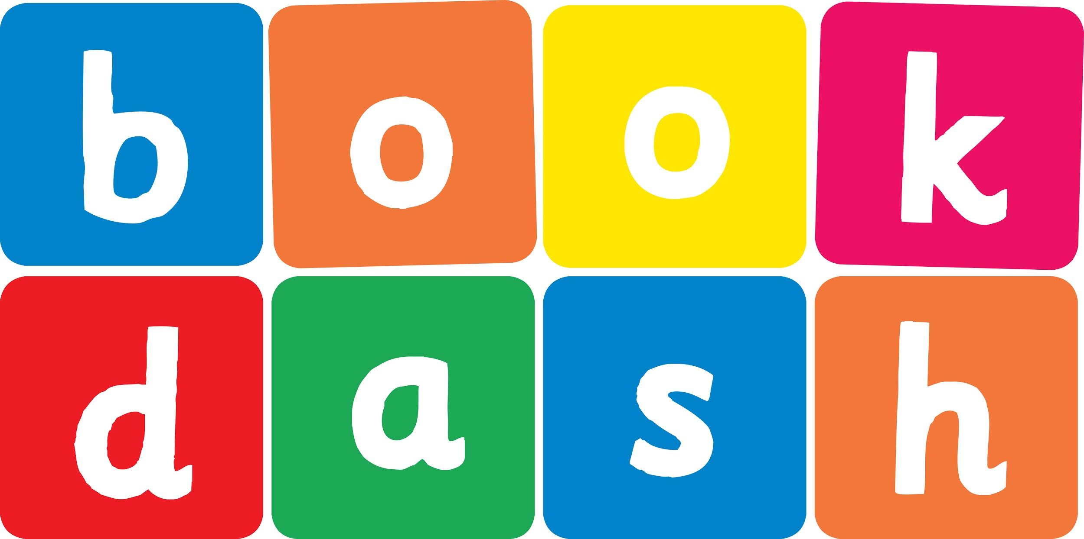
Book Dash Translation Template

Instructions
- If no text appears on a page, please indicate this in the cell with “N/A”
- Please save this file using the format: english-title_language.doc. For example: singing-the-truth_isixhosa.doc

Book Title in English: | No!
Language of Translation: | IsiXhosa
Translated Title: | Hayi!
Translator’s full name and/or organisation: | Sihle Siko

Page | English | Translation
Cover | No! | Hayi!
Inside front cover | No text | NA
Book-plate page. | No!  This book belongs to | Hayi!  Le ncwadi yeka
Endpapers. | No text | NA
Endpapers. | No text | NA
Copyright page. No need to translate. | No translation | NA
Title page. | No! | Hayi!
6
7 | Nosisi, it’s time to stop playing.  Please come inside? | Nosisi, lixesha lokuyeka ukukudlala.  Nceda ungene ngaphakathi?
8
9 | No! | Hayi!
10 | Nosisi, we need to go to the shops. | Nosisi, kufuneka siye ezivenkileni.
11 | No! | Hayi!
12
13 | Look at these beautiful butterflies.  No! | Jonga la mabhabhathane amahle.  Hayi!
14 | Come help Mama make some r ice. | Yiza kuncedisa uMama ukwenza irayisi.
15 | No! | Hayi!
16
17 | Let’s feed Shakes.  No! | Masiphe uShakes ukutya.  Hayi!
18
19 | Nosisi it’s bath time…  No! | Nosisi lixesha lokuhlamba…  Hayi!
20 | No  No  No | Hayi  Hayi  Hayi
21 | No!  Nonononono… | Hayi!  Hayihayihayihayihayi…
22
23 | How about an ice cream?  No! | Kunjani nge-ayiskhrimu?  Hayi!
24 | Oh.  Not no… | Yho.  Andithi hayi…
25
26 | Yes!  Yummy. Yummy. | Ewe!  Mnandi. Mnandi.
27 | Yay!  Yay!  Yay! | Ewe!  Ewe!  Ewe!
28 | Nosisi, will you tidy your room? | Nosisi, uza kulicoca igumbi lakho?
29 | Hmmmm. Well…okay. | Mmmmm. Eee… kulungile
30
31
32
Endpapers. | No text | NA
Endpapers. | No text | NA
Blank or decoration. | No translation unless there is text
Inside back cover. | No text | NA
Back cover | A certain little girl in the habit of saying ‘No’.  She says it a lot. In fact, all the of time.  One day though, she is faced with a very tempting question and can’t help but say ‘YES’! | Intombazana ethile encinci inomkhwa wokuthi ‘Hayi’.  Usoloko esitsho rhoqo. Eneneni, ngalo lonke ixesha.  Ngenye imini nakuba kunjalo, ujongana nombuzo omhenda kakhulu aze angakwazi kuzinceda kodwa athi ‘EWE’!

