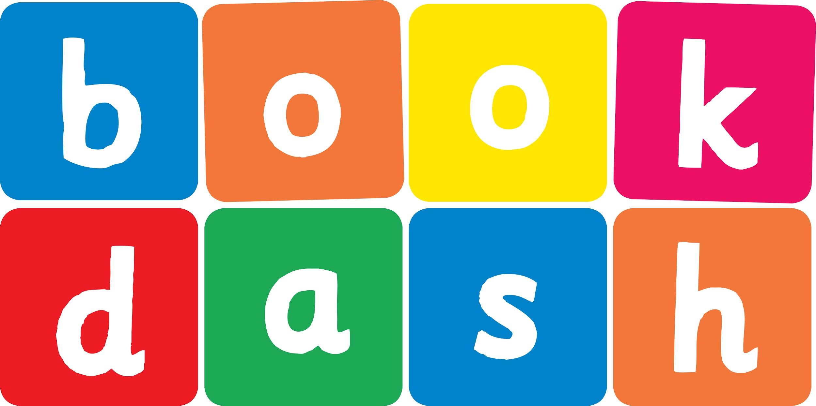
Book Dash Translation Template

Instructions
- If no text appears on a page, please indicate this in the cell with “N/A”
- Please save this file using the format: english-title_language.doc. For example: singing-the-truth_isixhosa.doc

Book Title in English: | No!
Language of Translation: | IsiZulu
Translated Title: | Cha!
Translator’s full name and/or organisation: | Nonkululeko Nhlapo

Page | English | Translation
Cover | No! | Cha!
Inside front cover | No text | NA
Book-plate page. | No!  This book belongs to | Cha!  Le ncwadi ngeka
Endpapers. | No text | NA
Endpapers. | No text | NA
Copyright page. No need to translate. | No translation | NA
Title page. | No! | Cha!
6
7 | Nosisi, it’s time to stop playing.  Please come inside? | Nosisi, sesiphelile isikhathi sokudlala. Ngicela ungene endlini.
8
9 | No! | Cha!
10 | Nosisi, we need to go to the shops. | Nosisi, kumele siye ezitolo.
11 | No! | Cha!
12
13 | Look at these beautiful butterflies.  No! | Buka lezi zimvemvane ezinhle.  Cha!
14 | Come help Mama make some rice. | Woza uzosiza uMama ukuze enze ilayisi.
15 | No! | Cha!
16
17 | Let’s feed Shakes.  No! | Asiphakele uShakes.  Cha!
18
19 | Nosisi it’s bath time...  No! | Nosisi sekuyisikhathi sokugeza...  Cha!
20 | No  No  No | Cha  Cha  Cha
21 | No!  Nonononono... | Cha!  Chachachachacha...
22
23 | How about an ice cream?  No! | Ungawuthokozela u-ayisikhlimu?  Cha!
24 | Oh.  Not no... | Hawu.  Hhayi angithi cha...
25
26 | Yes!  Yummy. Yummy. | Yebo!  Umnandi. Umnandi
27 | Yay!  Yay!  Yay! | Yebo!  Yebo!  Yebo!
28 | Nosisi, will you tidy your room? | Nosisi, uzoqoqa kahle egumbini lakho?
29 | Hmmmm. Well... okay. | Hmmmm. Hhayi... kulungile.
30
31
32
Endpapers. | No text | NA
Endpapers. | No text | NA
Blank or decoration. | No translation unless there is text | NA
Inside back cover. | No text | NA
Back cover | A certain little girl is in the habit of saying ‘No’.  She says it a lot. In fact, all of the time.  One day though, she is faced with a very tempting question and can’t help but say ‘YES!’  Perhaps saying ‘Yes’ isn’t so bad after all. | Kunentombazanyana enomkhuba wokuthi ‘Cha’.  Ukusho lokhu kakhulu. Eqinisweni, ngaso sonke isikhathi.  Kodwa ngelinye ilanga, uhlangabezana nombuzo omyengayo kangangokuba akanayo enye indlela ngaphandle kokuthi ‘YEBO!’  Mhlawumbe akukubi kangakho ukuthi ‘Yebo’ ekugcineni.

