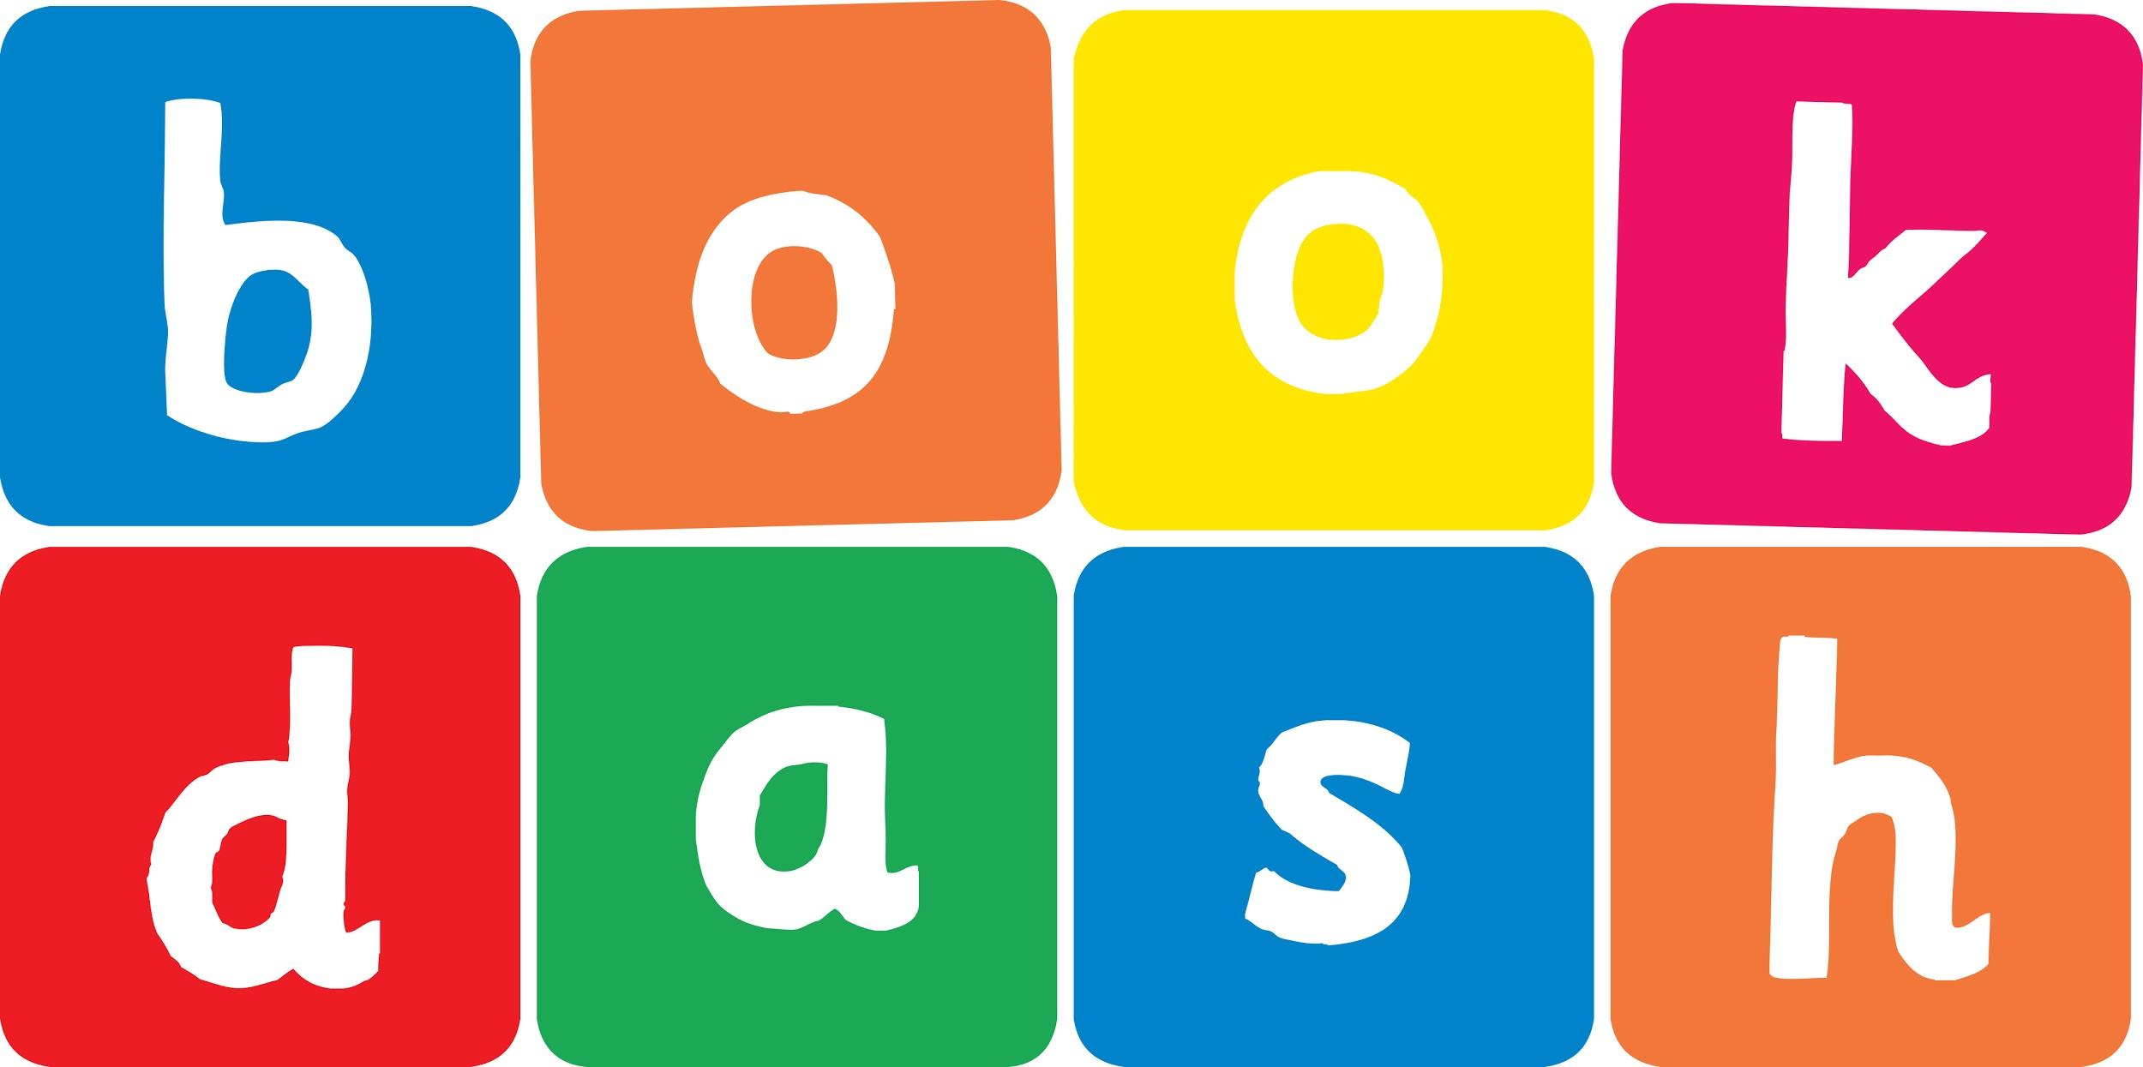
Book Dash Translation Template

Instructions
- If no text appears on a page, please indicate this in the cell with “N/A”
- Please save this file using the format: english-title_language.doc. For example: singing-the-truth_isixhosa.doc

Book Title in English: | Scared Tumi
Language of Translation: | IsiXhosa
Translated Title: | UTumi owoyikayo
Translator’s full name and/or organisation: | Sihle Siko

Page | English | Translation
Cover | Scared Tumi | UTumi owoyikayo
Inside front cover | No text | NA
Book-plate page. | Scared Tumi  This book belongs to | UTumi owoyikayo  Le ncwadi yeka
Endpapers. | No text | NA
Endpapers. | No text | NA
Copyright page. No need to translate. | No translation | NA
Title page. | Scared Tumi | UTumi owoyikayo
5
6 | My name is Tumi.  I am scared | Igama lam nguTumi.  Ndiyoyika.
7
8 | Mama says it’s okay to be scared.  “Everybody gets scared.” | UMama uthi kulungile ukoyika.  “Wonke umntu ukhe oyike.”
9
10 | What if there is a monster under my bed? | Kungathini ukuba kukho irhamncwa phantsi kwebhedi yam?
11
12 | “Then I will tell it to go away and NEVER come back.” | “Ngoko ke ndiya kulixelela ukuba lihambe LINGAZE libuye.”
13
14 | What if there are eyes in the bath tub drain? | Kungathini ukuba kukho amehlo kwidreyini yebhafu?
15
16 | “Then your big sister, Kamo, will pull you out of the bath.” | Ngoko ke usisi wakho omdala, uKamo, uya kukukhupha ebhafini.”
17
18 | What if a whale swallows me at the beach? | Kungathini ukuba umnenga uyandiginya elwandle?
19
20
21 | “Then Kamo and I will swim into the whale’s mouth to rescue you.” | “Ngoko ke mna nosisi wakho uKamo siya kudada singene emlonyeni womnenga sikuhlangule.”
22 | What if I can’t sing ABC and the other kids laugh at me? | Kungathini ukuba mna andikwazi ukucula uABC baze abanye abantwana bandihleke?
23
24 | “Then teacher Jill will help you remember.” | “ Ngoko ke utisthalakazi uJill uya kukunceda ukhumbule.”
25
26 | What if I am scared of going to the dentist tomorrow? | Kungathini ukuba ndiyoyika ukuya kugqirha wamazinyo ngomso?
27
28 | “I will be right there holding your hand.”  Everybody gets scared. Mama says it’s okay. | “Ndiza kuba ndikhona ndibambe isandla sakho.”  Wonke umntu ukhe oyike. Umama uthi kulungile.
29
30
31
32
Endpapers. | No text | NA
Endpapers. | No text | NA
Blank or decoration. | No translation unless there is text
Inside back cover. | No text | NA
Back cover | “What if there is a monster under my bed?”  Tumi is scared.  Mama tries to show him that everything is okay. | “Kungathini ukuba kukho igongqongqo phantsi kwebhedi yam?”  UTumi uyoyika.  UMama uzama ukumbonisa ukuba yonke into ilungile.

