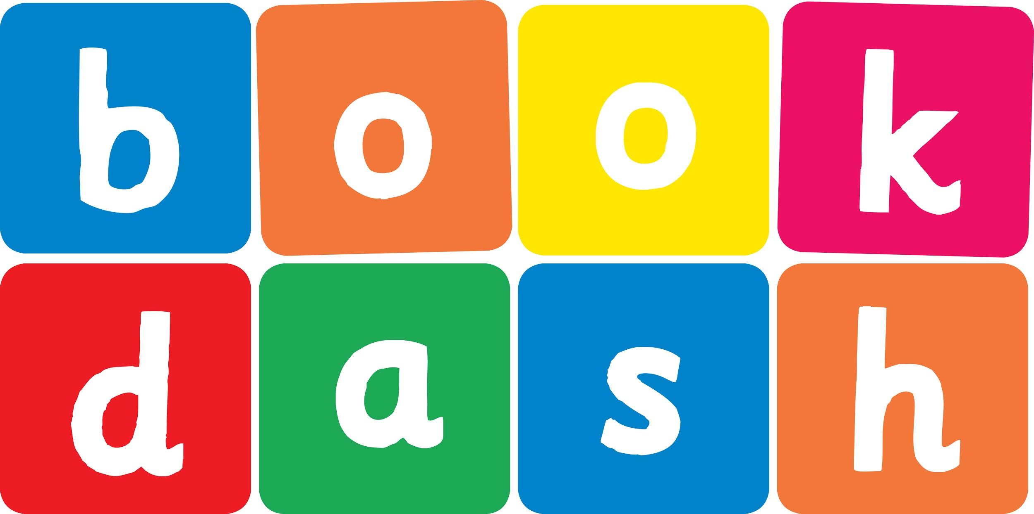
Book Dash Translation Template

Instructions
- If no text appears on a page, please indicate this in the cell with “N/A”
- Please save this file using the format: english-title_language.doc. For example: singing-the-truth_isixhosa.doc

Book Title in English: | SHONGOLOLO’S shoes
Language of Translation: | IsiXhosa
Translated Title: | Izihlangu zikaSONGOLOLO
Translator’s full name and/or organisation: | Sihle Siko

Page | English | Translation
Cover | SHONGOLOLO’S shoes | Izihlangu zikaSONGOLOLO
Inside front cover | No text | NA
Book-plate page. | SHONGOLOLO’S shoes  This book belongs to | Izihlangu zikaSONGOLOLO  Le ncwadi yeka
Endpapers. | No text | NA
Endpapers. | No text | NA
Copyright page. No need to translate. | No translation | NA
Title page. | SHONGOLOLO’S shoes | Izihlangu zikaSONGOLOLO
5 | Where are all my shoes?  I know I left them here! | Ziphi izihlangu zam zonke?  Ndiyazi ukuba bendizishiye apha!
6
7
8 | I haven’t seen your shoes.  Go ask Snail! | Andikhange ndizibone izihlangu zakho.  Hamba uyokubuza uNkumbamdodo!
9
10 | No shoes here.  Go ask Giraffe. | Akukho zihlangu apha.  Hamba uyokubuza uNdlulamthi.
11
12
13 | I am in a hurry – go ask Frog. | Ndingxamile – hamba uyokubuza uSelesele.
14 | Shoes? How many?  Go ask Flamingo. | Izihlangu? Ezingaphi?  Hamba uyokubuza uKholwase.
15
16
17 | Seen your shoes?  No, not me. | Ndizibonile izihlangu zakho?  Hayi, hayi mna.
18
19 | Will I ever find my shoes? | Ingaba ndiya kuze ndizifumane izihlangu zam?
20
21 | Shoes, eh?  You should ask the Monkeys. | Izihlangu, utsho?  Kufuneka ubuze iiNkawu.
22 | Hello hello? | Molweni molweni?
23 | We’re busy. Go ask Owl, she knows everything! | Sixakekile thina. Hamba uyokubuza uSikhova, wazi yonke into!
24
25 | Hmm. I have an idea.  Why don’t you ask Lion? | Hmm. Ndinecebo.  Kutheni ungabuzi uNgonyama nje?
26
27 | These are all yours?  I’ll give them all back if you come to my party! | Zezakho zonke ezi?  Ndiza kuzibuyisela zonke kuwe ukuba uyeza kwitheko lam!
28
29
30
31
32
Endpapers. | No text | NA
Endpapers. | No text | NA
Blank or decoration. | No translation unless there is text
Inside back cover. | No text | NA
Back cover | Shongololo has lost his shoes, and the other animals are NOT being very helpful. Will he ever find them? | USongololo ulahlekwe zizihlangu zakhe, yaye ezinye izilwanyana AZIloncedo konke konke. Ingaba uya kuze azifumane?

