3333333333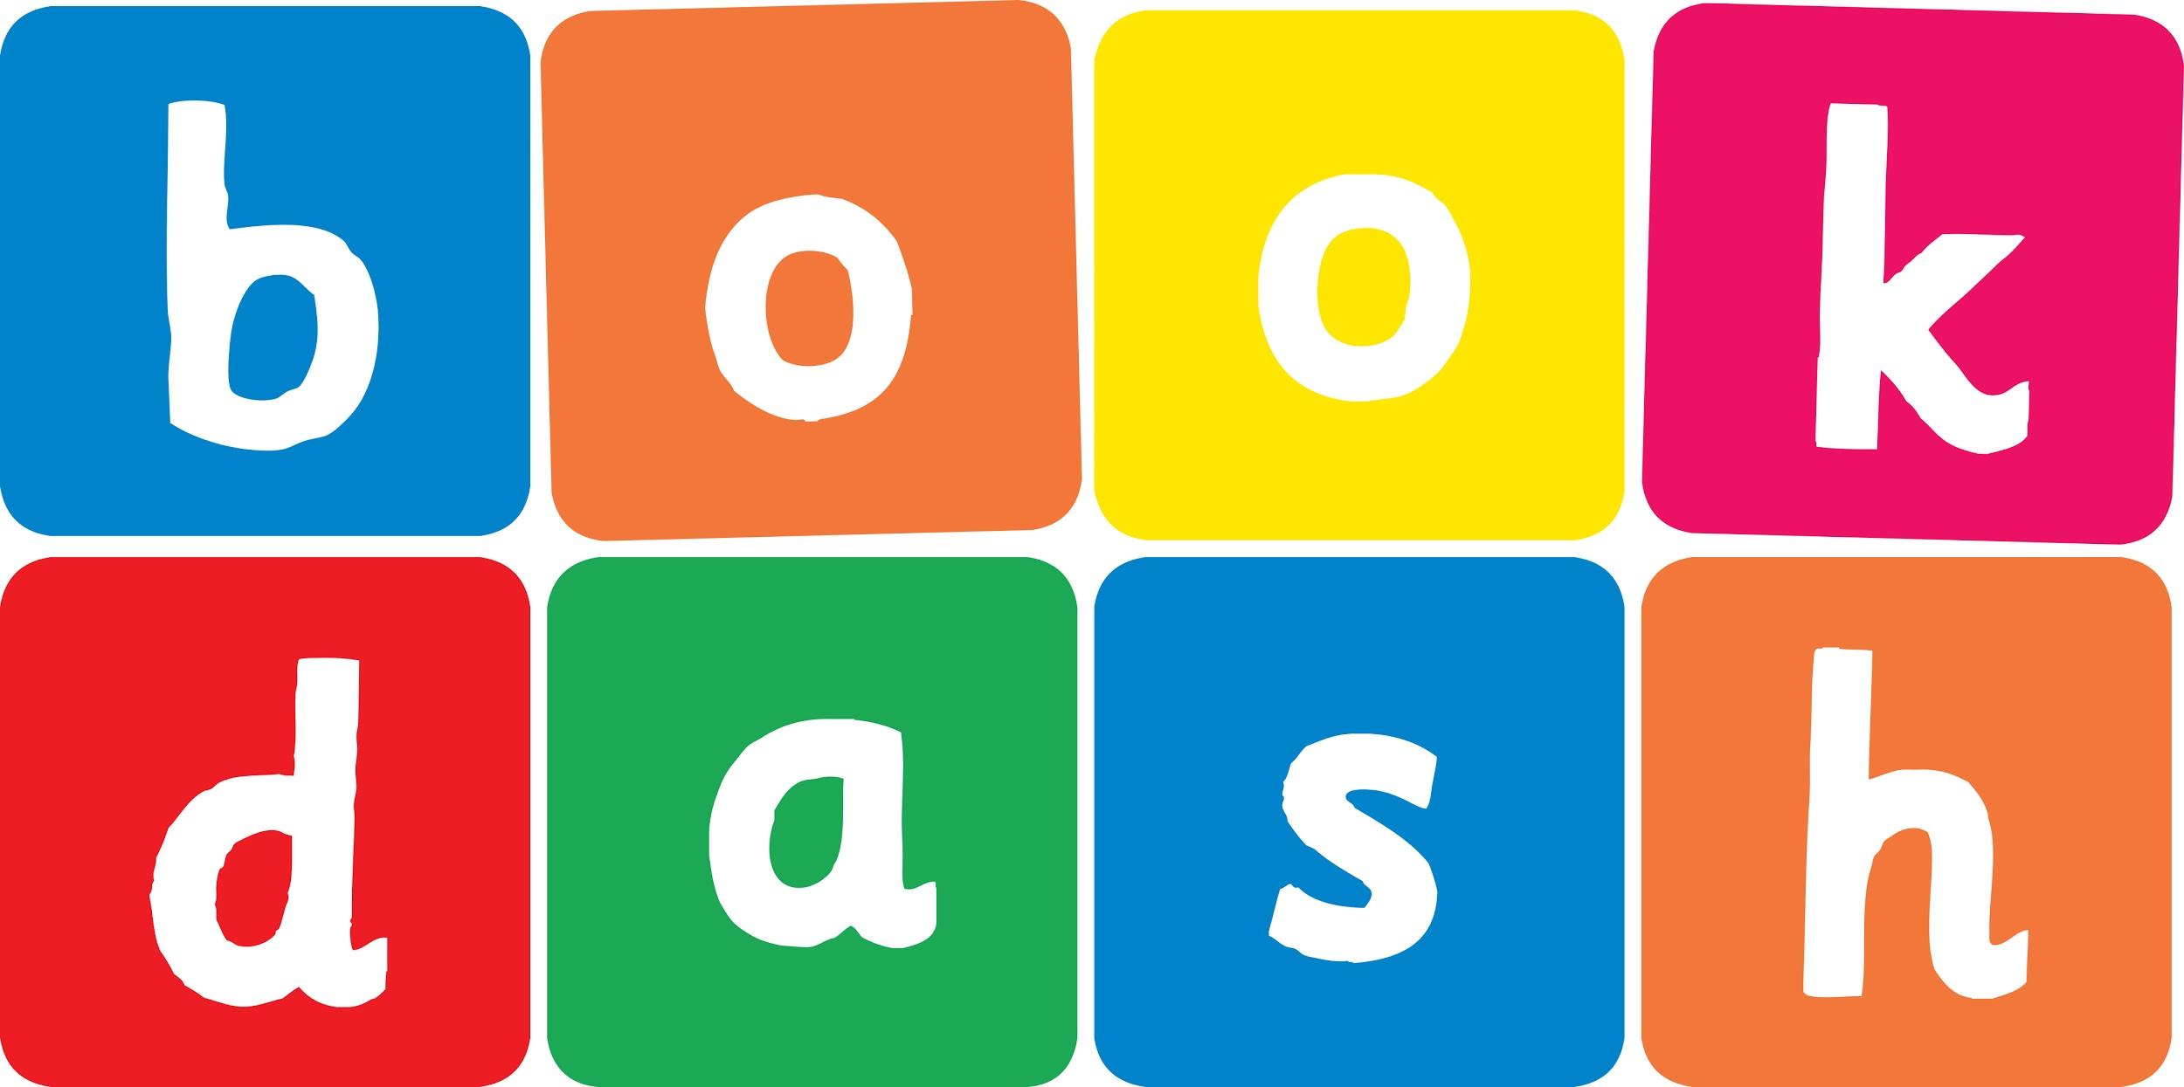
Book Dash Translation Template

Instructions
- If no text appears on a page, please indicate this in the cell with “N/A”
- Please save this file using the format: english-title_language.doc. For example: singing-the-truth_isixhosa.doc

Book Title in English: | Shongololo’s Shoes
Language of Translation: | IsiZulu
Translated Title: | Izicathulo zikaShongololo
Translator’s full name and/or organisation: | Nonkululeko Nhlapo

Page | English | Translation
Cover | Shongololo’s Shoes | Izicathulo zikaShongololo
Inside front cover | No text | NA
Book-plate page. | Shongololo’s Shoes  This book belongs to | Izicathulo zikaShongololo  Le ncwadi ngeka
Endpapers. | No text | NA
Endpapers. | No text | NA
Copyright page. No need to translate. | No translation | NA
Title page. | Shongololo’s Shoes | Izicathulo zikaShongololo
1 (leave blank if no text)
5
6 | Where are all my shoes?  I know I left them here! | Ziphi izicathulo zami zonke?  Ngiyazi ukuthi ngizishiye lana!
7
8 | I haven’t seen your shoes.  Go ask Snail! | Angizibonanga izicathulo zakho.  Hamba uyobuza uMnenke!
9
10 | No shoes here.  Go ask Giraffe. | Azikho izicathulo lapha.  Hamba uyobuza uNdlulamithi.
11
12
13 | I’m in a hurry – go ask Frog. | Ngiyaphuthuma – hamba uyobuza uXoxo.
14 | Shoes? How many?  Go ask Flamingo. | Izicathulo? Ezingaki?  Hamba uyobuza uMakholwane.
15
16
17 | Seen your shoes?  No, not me. | Uthi ngibone izicathulo zakho?  Cha, hhayi mina.
18
19 | Will I ever find my shoes? | Ngiyoke ngizithole kodwa izicathulo zami?
20
21 | Shoes, eh?  You should ask the Monkeys. | Izicathulo, hhe?  Kumele ubuze Izinkawu.
22 | Hello hello? | Sanibonani sanibonani?
23 | We’re busy. Go ask Owl, she knows everything! | Simatasa. Hamba uyobuza uSikhova, uyena owazi konke!
24
25 | Hmm. I have an idea.  Why don’t you ask Lion? | Uhmm, nginombono.  Kungani ungabuzi uBhubesi?
26
27 | These are yours?  I’ll give them all back  if you come to my party! | Ezakho lezi?  Ngizokubuyisela zona zonke uma uza ephathini yami!
28
29
30
Endpapers. | No text | NA
Endpapers. | No text | NA
Blank or decoration. | No translation unless there is text
Inside back cover. | No text | NA
Back cover | Shongololo has lost his shoes, and the other animals are NOT being very helpful. Will he ever find them? | UShongololo ulahlekelwe yizicathulo zakhe, kanti ezinye izilwane AZIMSIZI ngalutho. Uzoke azithole kodwa?

