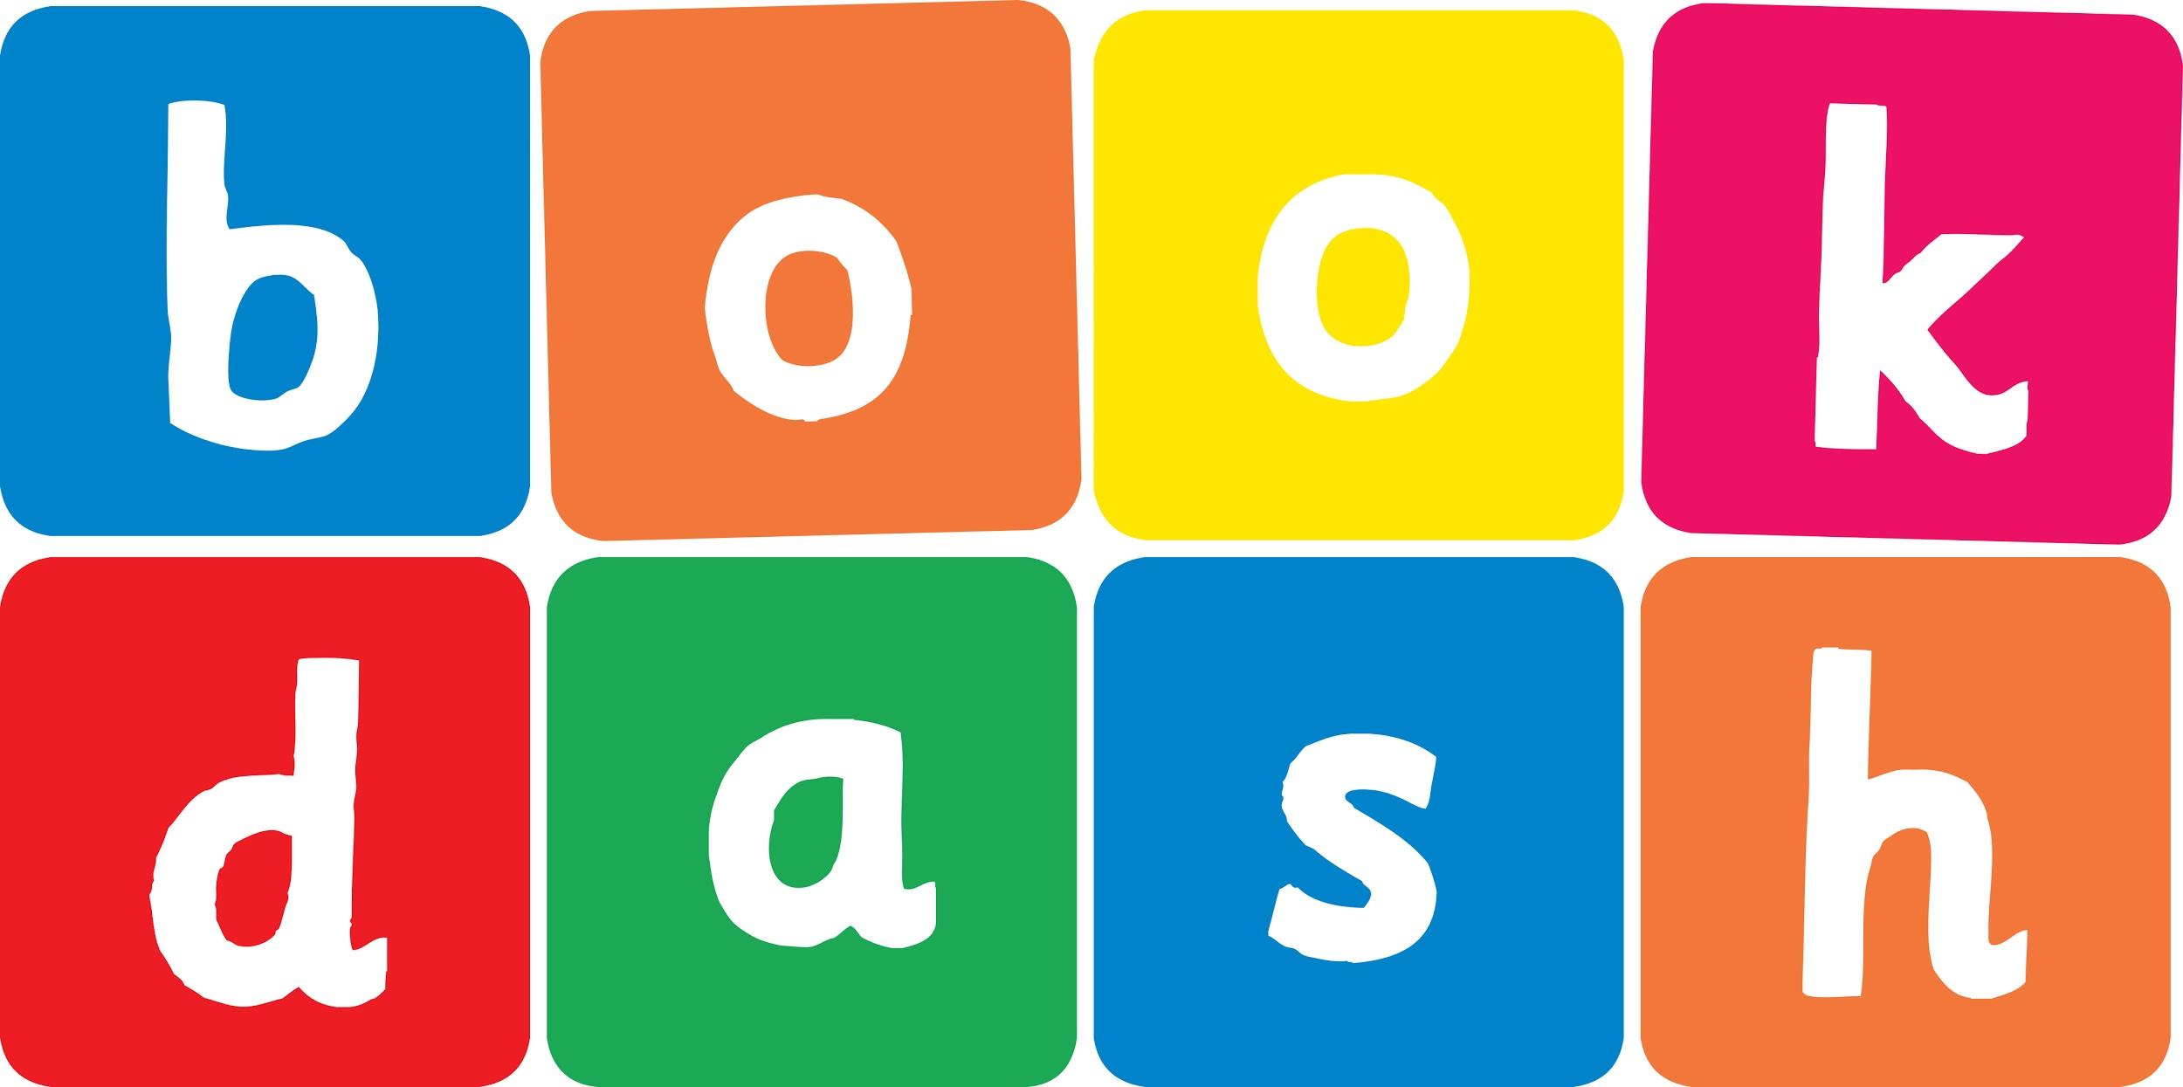
Book Dash Translation Template

Instructions
- If no text appears on a page, please indicate this in the cell with “N/A”
- Please save this file using the format: english-title_language.doc. For example: singing-the-truth_isixhosa.doc

Book Title in English: | The Things That Really Matter
Language of Translation: | IsiZulu
Translated Title: | Izinto Ezibaluleke Kakhulu
Translator’s full name and/or organisation: | Nonkululeko Nhlapo

Page | English | Translation
Cover | The Things That Really Matter | Izinto Ezibaluleke Kakhulu
Inside front cover | No text | NA
Book-plate page. | The Things That Really Matter  This book belongs to | Izinto Ezibaluleke Kakhulu  Le ncwadi ngeka
Endpapers. | No text | NA
Endpapers. | No text | NA
Copyright page. No need to translate. | No translation | NA
Title page. | The Things That Really Matter | Izinto Ezibaluleke Kakhulu
1 (leave blank if no text)
2
3
4
5 | Things that really matter | Izinto ezibaluleke kakhulu
6
7 | We are going on a trip. I ask mama what to pack.  She says, “The things that really matter.” | Sinohambo esizoluthatha. Ngibuza umama ukuthi ngipakishe ini.  “Izinto ezibaluleke kakhulu,” kusho yena.
8 | We stop at the windmill for breakfast. The jungle gym is so much fun. | Sima ku-windmill lapho esidle khona isidlo sasekuseni.  Kunendawo yokudlala okumnandi kakhulu ukudlala kuyona.
9 | I forget my toy. | Ngikhohlwe ithoyizi lami.
10
11 | I am sad in the car, but Tando is happy.  ‘Hooray! Now you can play with ME!’ he says | Ngiphatheke kabi emotweni, kodwa uTando ujabulile.  ‘Halala! Manje usuzokwazi ukudlala NAMI!’ kusho yena.
12 | We stop at a farm to see some animals. Tando is searching so hard for a springbok | Sima epulazini ukuze sibone izilwane. UTando ulokhu eqalaze njalo ufuna ukubona insephe.
13 | A monkey gets away with his headphones. | Inkawu isibaleke nama-headphone akhe.
14
15 | He is sad in the car, but I am happy  ‘Hooray! Now you can sing with ME!” I say. | Usephatheke kabi emotweni, kodwa mina ngijabulile.  ‘Halala! Manje usuzokwazi ukucula NAMI!’ kusho mina.
16 | We stop at a roaming waterfall. We are so excited, we are pushing and pulling. | Sima ngasempophomeni. Sithakase kakhulu, siyadonsa siyadudula.
17 | Papa falls in the water and so does his map. | Ubaba uwele emanzini nebalazwe lakhe.
18
19 | He is sad in the car, but mama is happy.  ‘Hooray! Now I can help you find OUR way!’ she says. | Usephatheke kabi emotweni, kodwa umama ujabulile.  ‘Halala! Manje sengizokusiza uthole indlela YETHU!’ kusho yena.
20 | We stop at the roadside vendor to buy some mielies. | Sima eduze komuntu odayisa emgwaqeni ukuze sithenge ummbila.
21 | Mama bends over to pick the best ones and her glasses fall and break. | Umama uyagoba ukhetha ummbila omuhle kakhulu, kwavele kwawa izibuko zakhe zaphuka.
22
23 | Mama is sad in the car, but papa is happy.  ‘hooray! Now we can find our wat TOGETHER!’ says papa. | Umama usephatheke kabi emotweni, kodwa ubaba ujabulile.  ‘Halala! Manje sesizothola indlela yethu SONKE!’ kusho ubaba.
24 | We stop on an ancient hill to get a view of the valley. Papa is making a silly joke for us to smile for the picture. | Sima egqumeni lasemandulo ukuze sibone kahle esigodini. Ubaba wenza ihlaya ukuze simamatheke njengoba sithatha isithombe.
25 | But… | Kodwa…
26
27 | When we get back to the car, it won’t start.  Everyone stops laughing.  ‘Don’t worry…’ says mama. ‘We can still have a good time. We are the things that really matter.’ | Uma sesibuyela emotweni, ayisadumi.  Wonke umuntu usevele wayeka ukuhleka.  ‘Ningakhathazeki ...’ kusho umama. ‘Singaqhubeka nokuba nesikhathi esimnandi. Thina siyizo lezinto ezibaluleke kakhulu.’
28
29 | And so we do have a good time.  By playing and singing and finding our way together, while enjoying the best mielies | Futhi ngempela saba nesikhathi esimnandi. Sadlala futhi sacula futhi sizicingela indlela yethu sindawonye, sidla nommbila omnandi.
30
Endpapers. | No text | N/A
Endpapers. | No text | N/A
Blank or decoration. | No translation unless there is text | N/A
Inside back cover. | No text | N/A
Back cover | What are the most important things to take with you on a trip?  Join Zuki, Tando, Mama and Papa on their eventful journey to find out. | Yiziphi izinto ezibaluleke kakhulu ongaziphatha uma unohambo?  Hlanganyela noZuki, uTando, uMama noBaba ohambweni lwabo ulunezigigaba uzothola kabanzi ngazo.

