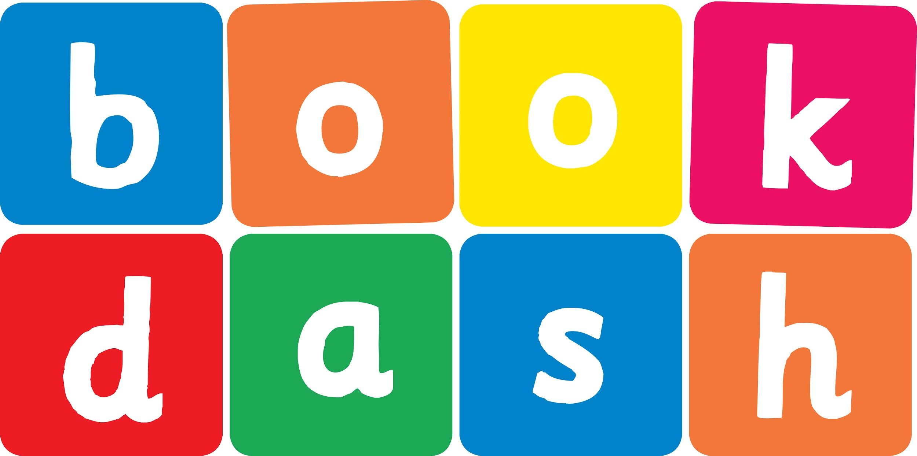
Book Dash Translation Template

Instructions
- If no text appears on a page, please indicate this in the cell with “N/A”
- Please save this file using the format: english-title_language.doc. For example: singing-the-truth_isixhosa.doc

Book Title in English: | Tortoise Finds His Home
Language of Translation: | isiXhosa
Translated Title: | UFudo ufumene ikhaya lakhe
Translator’s full name and/or organisation: | Nal’ibali

[Inside front cover]
[Copyright page. No need to translate.] | UFudo ufumene ikhaya lakhe
[Endpapers. No translation] | [Endpapers. No translation]
1 | 2 n/a
3 Ngenye imini uFudo wayehamba-hamba ethafeni. Wayekhanga-khangela efuna-funa. Waqwalasela mgama, encine namehlo kuloo ngca.  Waza ke wadlula kuNkumba.  “Ingaba kukho into oyikhangelayo?” wabuza uNkumba.  “Ewe Nkumba, ndikhangela indlu yam. Ingaba ukhe wayibona?” kubuza uFudo. | 4 UNkumba wathi, “Hayi, andikhange ndiyibone, kodwa ndiza kukukhangelisa!”  Wakhwela ke kwiqokobhe likaFudo. UFudo wahamba ebeleke uNkumba emhlana. Bakhangela bakhangela, kodwa kwakungekho nomncinci umkhondo wendlu yakhe. Ilanga lalisele lenyukele phezulu esibhakabhakeni.
5 Emva kwethutyana badlula kuNgqatyana.  “Ingaba kukho into eniyikhangelayo?” wabuza uNgqatyana.  “Ewe Ngqatyana, ndikhangela indlu yam. Ingaba ukhe wayibona?” wabuza uFudo.  UNgqatyana wathi, “Hayi, khange ndiyibone, kodwa ndiza kunikhangelisa!” | 6 Waphakuzelisa iimpiko zakhe, wabhabha, wakhokela uNgqatyana.  “Kodwa ukhawuleza kakhulu kunam,” ukhalaze watsho uFudo.  UNgqatyana wabuya kwa oko. “Kulungile ke, ndiza kubelekeka ke nam.”  UFudo waqhubeka nohambo lwakhe, ebeleke uNkumba noNgqatyana. Bakhangela bakhangela, kodwa kwakungekho mkhondo wandlu. Ilanga lalisele lithambeka ngoku.
7 Emva kwethutyana badlula kuBhantom. “Ingaba kukho into eniyikhangelayo?” wabuza uBhantom.  “Ewe Bhantom, ndikhangela indlu yam. Ingaba ukhe wayibona?” kubuza uFudo. | 8 UBhantom wathi, “Hayi, khange ndiyibone, kodwa ndiza kunikhangelisa!”  UBhantom watsibela emqolo kuFudo waza ke uFudo waqhubeka nohambo, ebeleke uNkumba, uNgqatyana noBhantom.  Bakhangela bakhangela, kodwa kwakungekho mkhondo wandlu. Ngoku ke kwakusele kuqalisa umoyana ohlabayo.
9 Emva kwexeshana badlula kuMpuku. Wayebekelela isangqa seentyatyambo.  “Ingaba kukho into eniyikhangelayo?” wabuza uMpuku.  “Ewe Mpuku, ndikhangela indlu yam. Ingaba ukhe wayibona?” kwabuza uFudo.  UMpuku wathi, “Hayi khange ndiyibone, kodwa ndiza kunikhangelisa!”  Watsibela kumqolo woFudo naye. | 10 UFudo waqhubeka nohambo lwakhe, ebeleke uNkumba, uNgqatyana, uBhantom, kunye noMpuku. Bakhangela bakhangela, kodwa kwakungekho mkhondo wandlu. Umoya wawuphaphathekisa amagqabi aze ajikeleze ngasezinyaweni zikaFudo.  UFudo wafunyanwa kukudinwa. “Nina niyandisinda,” watsho ngesingqala.  Umoya waya uqina ngokuqina. Isibhakabhaka saguquka saba mnyama.  “Owu, ingaba iphi na indlu yam?” Kwavakala iindudumo ezindulini. Kwalenyeza imibane mgama. Chapha-chapha yaqalisa ukunetha imvula.  “Owu, ingaba iphi indlu yoFudo?” kwabuza uNkumba, uNgqatyana, uBhantom kunye noMpuku.
11 n/a | 12 n/a
13 Umoya wavuthuza kakhulu. Waphaphathekisa uNkumba, uNgqatyana, uBhantom kunye noMpuku baya kuwa qelele. | 14 Emva koko kwalandela isichotho, qhufu-qhufu-qhufu. UFudo woyika kakhulu kangangokuba wazisonga wangena kwiqokobhe lakhe. Kwakushushu kamnandi ke apho.  “Owu, nantsi ke indlu yam!” watsho uFudo.
15 “Owu, nantsi ke indlu kaFudo!” | 16 n/a
[Endpapers. No translation] | [Endpapers. No translation]
[Blank or decoration. No translation] | [Inside back cover. No translation]

Back cover blurb:
Ngenye imini uFudo wayehamba-hamba ethafeni. Wayekhanga-khangela efuna-funa. Waqwalasela mgama, encine namehlo kuloo ngca…

