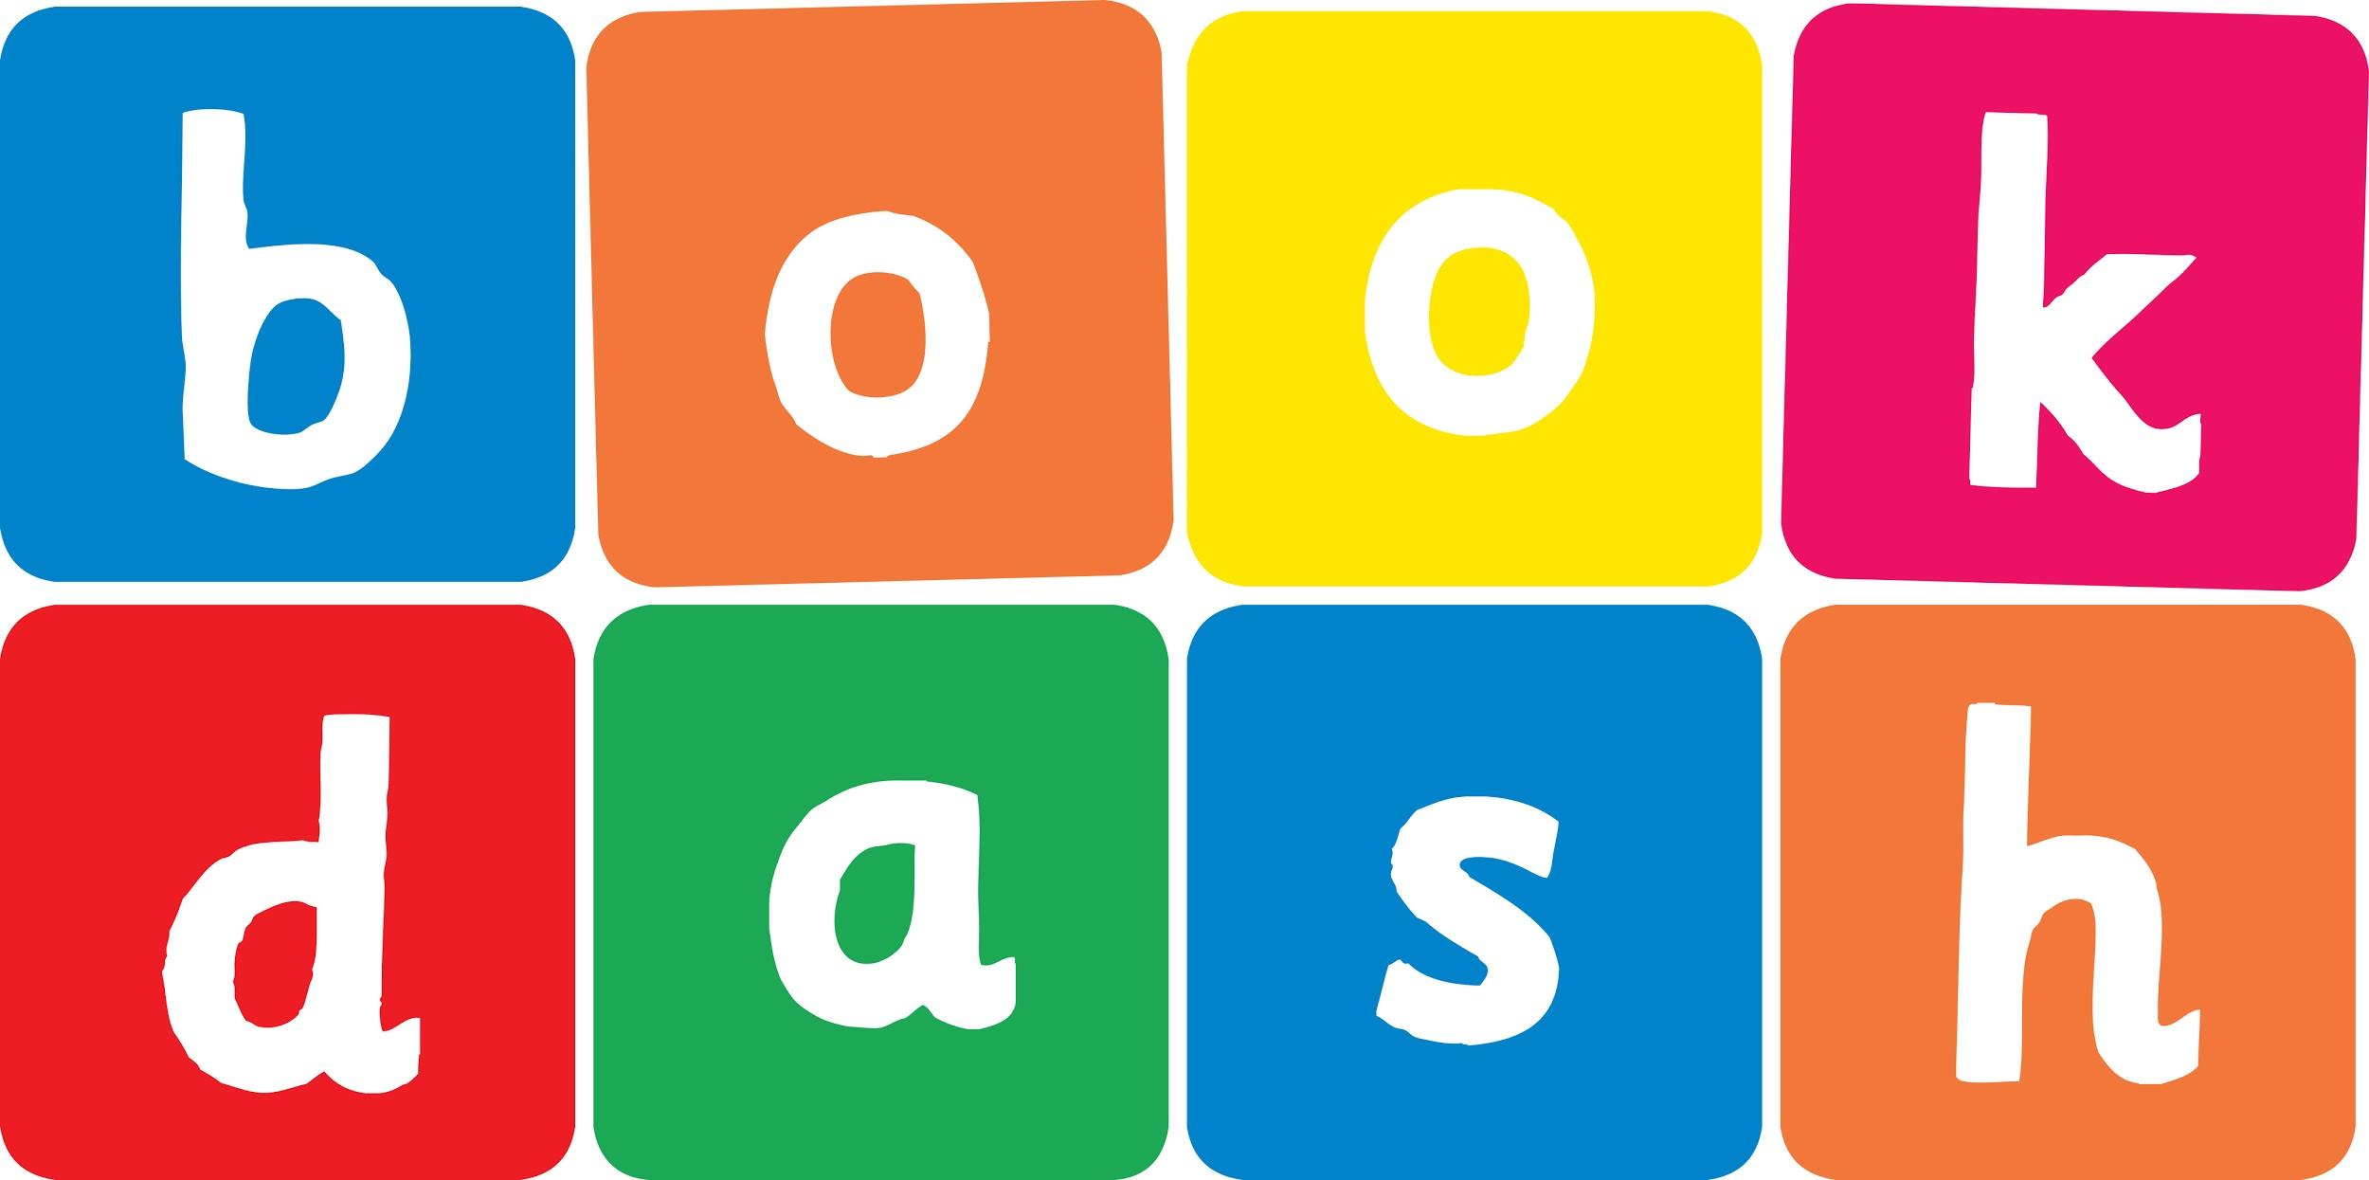
Book Dash Translation Template

Instructions
- If no text appears on a page, please indicate this in the cell with “N/A”
- Please save this file using the format: english-title_language.doc. For example: singing-the-truth_isixhosa.doc

Book Title in English: | Wiggle Jiggle
Language of Translation: | IsiZulu
Translated Title: | Shobi Shobi
Translator’s full name and/or organisation: | Nonkululeko Nhlapo

Page | English | Translation
Cover | Wiggle Jiggle | Shobi Shobi
Inside front cover | No text | NA
Book-plate page. | Wiggle Jiggle  This book belongs to | Shobi Shobi  Le ncwadi ngeka
Endpapers. | No text | NA
Endpapers. | No text | NA
Copyright page. No need to translate. | No translation | NA
Title page. | Wiggle Jiggle | Shobi Shobi
1 (leave blank if no text)
2
3
4
5
6 | Wiggle jiggle wriggle! | Shobi shobi shubi!
7 | I am a wiggly worm. | Ngingumsundu oshobizayo.
8 | Flowers and leaves are my favourite food. | Izimbali namaqabunga kungukudla engikuthandayo kakhulu. Kwaze kwamnandi
9 | my tummy! | esiswini sami!
10 | Wiggle jiggle wriggle! | Shobi shobi shubi!
11 | I am a wiggly worm. | Ngingumsundu oshobizayo.
12 | I love the rain.  Pitter-patter | Ngiyayithanda imvula.  Paqa-paqa-paqa
13 | on the leaves. | emaqabungeni.
14
15 | Watch me wiggle and dance.  Wiggle jiggle wriggle! | Ngibuke ngishobiza futhi ngidansa.  Shobi shobi shubi!
16 | POO!!! | BHU!!!
17 | My magic poo makes plants grow BIG. | Umquba wami wenza izitshalo zikhule zibe NKULU.
18
19 | I love to see my plants grow. Yellow, red, blue and green. | Ngiyathanda ukubona izitshalo zami zikhula. Eziphuzi, ezibomvu, eziluhlaza okwesibhakabhaka neziluhlaza okotshani.
20 | Wiggle jiggle | Shobi shobi
21 | wriggle! I am a wiggly worm. | shubi! Ngingumsundu oshobizayo.
22 | Wiggle when you see me in the garden. | Shobiza uma ungibona engadini.
23 | Wiggle jiggle wriggle! | Shobi shobi shubi!
24 | Where am I now? | Sengikuphi manje?
25 | I’m here in my cocoon! | Ngilapha egobolondweni lami!
26 | Oh wait! | Hhayibo yima!
27 | I’m not a wiggly worm! | Angiwona umsundu oshobizayo!
28 | Flitter flutter flitter!  I am a butterfly! | Bhaku bhaku bhaku!  Ngiwuvemvane!
29
30
Endpapers. | No text | NA
Endpapers. | No text | NA
Blank or decoration. | No translation unless there is text
Inside back cover. | No text | NA
Back cover | Wiggle jiggle wriggle with the wiggly worm, on a fun adventure that is full of surprises. | Shibilika nomsundu oshobizayo uthokozele ukuguquguquka okunezimangaliso.

