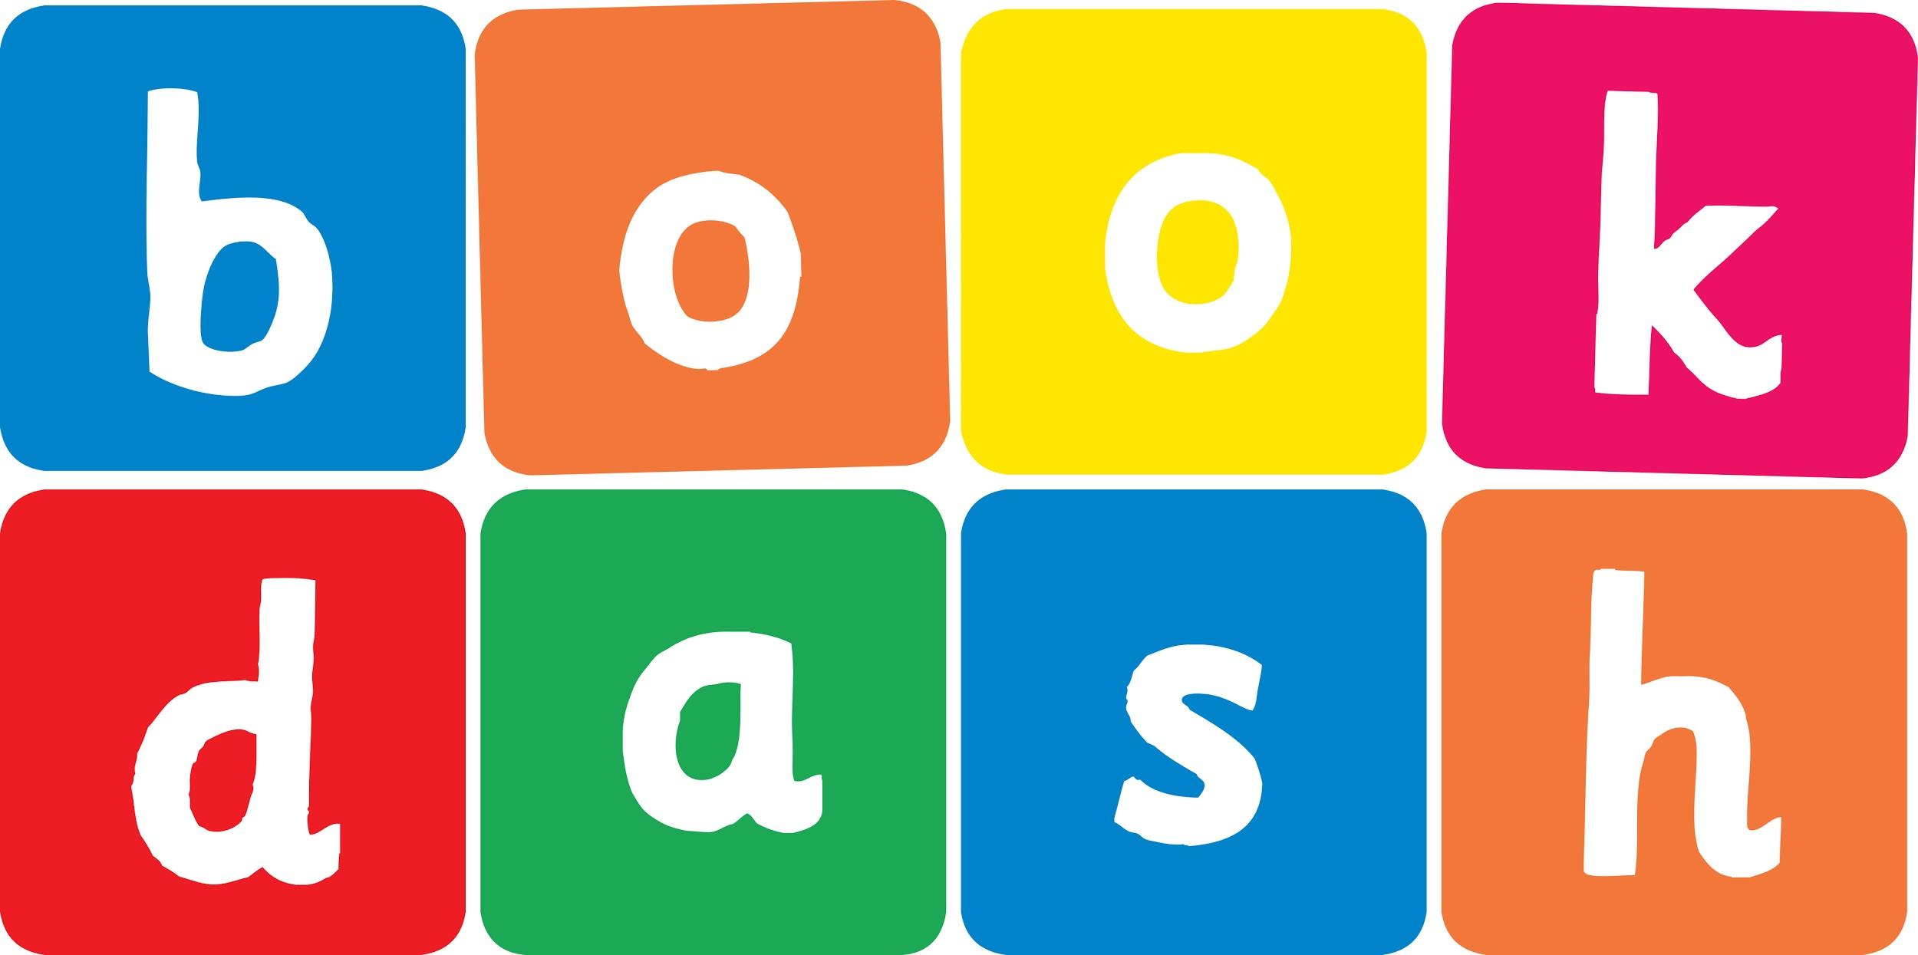
Book Dash Translation Template

Instructions
- If no text appears on a page, please indicate this in the cell with “N/A”
- Please save this file using the format: english-title_language.doc. For example: singing-the-truth_isixhosa.doc

Book Title in English: | A Beautiful Day
Language of Translation: | IsiXhosa
Translated Title: | Usuku Oluhle
Translator’s full name and/or organisation: | Sihle Siko

Page | English | Translation
Cover | A Beautiful Day | Usuku Oluhle
Inside front cover | No text | NA
Book-plate page. | A Beautiful Day  This book belongs to: | Usuku Oluhle  Le ncwadi yeka:
Endpapers. | No text | NA
Endpapers. | No text | NA
Copyright page. No need to translate. | No translation | NA
Title page. | Title A Beautiful Day | Usuku Oluhle
1 (leave blank if no text) | “What a beautiful day,” says Mom.  “Wake up Nicholas.” | “ Lwaze lwaluhle usuku,” utsho uMama.  “Vuka Nicholas.”
2 | “Hello sun,” says Nicholas.  “Good morning birds.” | “Molo langa,” utsho uNicholas.  “Molweni zintaka.”
3 | “It’s a lovely day,” says Dad.  “Let’s have a picnic by the river.” | “Lusuku oluhle,” utsho uTata.  “Masibe nepikiniki ngasemlanjeni.”
4 | “Can my friend Jacob come?” Asks Nicholas. | “Angeza umhlobo wam uJacob?” uyabuza uNicholas.
5 | “Don’t forget me, I love picnics!” says Donkey.  “And me. I want to come too!” says Dog. | “Ningandilibali nam, ndiyazithanda iipikiniki!” utsho uDonki.  “Nam. Ndifuna ukuza nam!” utsho uNja.
6 | “Follow us,” say the birds. | “Silandeleni,” zitsho iintaka.
7 | “I’ll race you to the tree,” says Nicholas. | “ Ndiza kubaleka nawe ukuya emthini,” utsho uNicholas.
8 | “I won, I won,” says Donkey.  “Not fair,” says Nicholas. “You’ve got four legs.” | “Ndiphumelele, ndiphumelele,” utsho uDonki.  “Ayinabulungisa le nto,” utsho uNicholas. “Wena unemilenze emine.”
9 | “Look what I can do,” says Nicholas. | “Jonga into endikwazi ukuyenza,” utsho uNicholas.
10 | “I bet you can’t do this,” says Jacob. | “Ndiqinisekile awunakukwazi ukwenza oku,” utsho uJacob.
11 | “Here’s our picnic sport,” says Dad. | “Nantsi indawo yethu yepikiniki,” utsho uTata.
12 | “Race you to the water,” says Jacob. | “Baleka uye emanzini,” utsho uJacob.
13 | “Come eat boys and girls,” says Mom. | “Yizani kutya makhwenkwe namantombazana,” utsho uMama.
14 | “Time to go home,” says Mom.  “Say goodbye to Jacob.” | “Lixesha lokugoduka,” utsho uMama.  “Valelisa kuJacob.”
15
16
17
18
19
20
21
22
23
24
Endpapers. | No text | NA
Endpapers. | No text | NA
Blank or decoration. | No translation unless there is text
Inside back cover. | No text | NA
Back cover | It’s a beautiful day for a picnic.  Everyone wants to join in the fun. | Lusuku oluhle lokwenza ipikiniki. Wonke umntu ufuna ukuzibandakanya kolu lonwabo.

