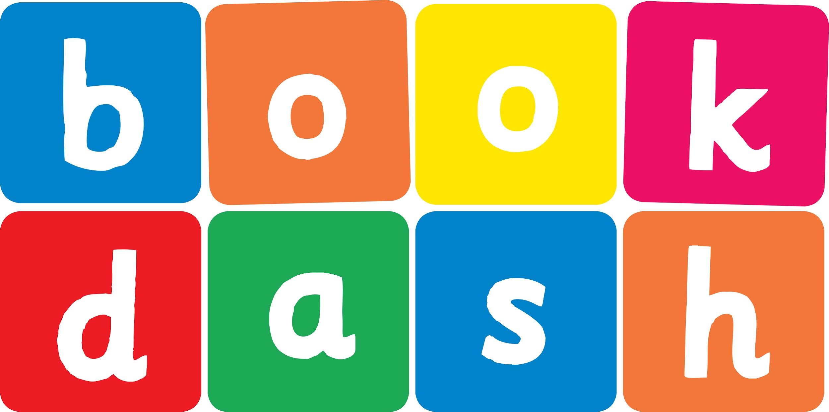
Book Dash Translation Template

Instructions
- If no text appears on a page, please indicate this in the cell with “N/A”
- Please save this file using the format: english-title_language.doc. For example: singing-the-truth_isixhosa.doc

Book Title in English: | A House for Mouse
Language of Translation: | Sesotho
Translated Title: | Ntlo bakeng sa Tweba
Translator’s full name and/or organisation: | Nal’ibali

[Inside front cover] | Bukaena ke ya:
[Copyright page. No need to translate.] | Ntlo bakeng sa Tweba
[Endpapers. No translation] | [Endpapers. No translation]
1 Tweba o ne a batlana le ntlo. | 2
3 Ena e shebeha eka ke ntlo e ntle. | 4
5 “O ka nna wa tlo robala le nna,”
ha rialo Mootlwana.

“Ke a leboha,” ha araba Tweba.

7 Bosiung boo, ditoro tsa Tweba di ne di tletse ho kukunela le ho tshosa. | 8
9 “O ka nna wa tla robala le nna,” ha rialo Papagae.  “Ke a leboha,” ha araba Tweba. | 10
11 Bosiung boo, ditoro tsa tweba di ne di tletse lerata di bile di le moferefere. | 12
13 “O ka nna wa tla robala le nna,” ha rialo Tlhapi.  “Ke a leboha,” ha araba Tweba. | 14
15 Bosiung boo, ditoro tsa Tweba e ne e le tse batang le tse metsi feela. | 16
17 Tweba o ne a batla moo ho futhumetseng ho bile  ho omme. | 18
19 | 20
21 Tweba a fumana shelofo ya dibuka haufi le moo. | 22
23 Bosiung boo, Tweba a ba le ditoro tse mofuthu
tse monate.
[Endpapers. No translation] | [Endpapers. No translation]
Robala hantle, Tweba. | [Inside back cover. No translation]

Back cover blurb:
Tweba o ne a batlana le ntlo…

