3333333333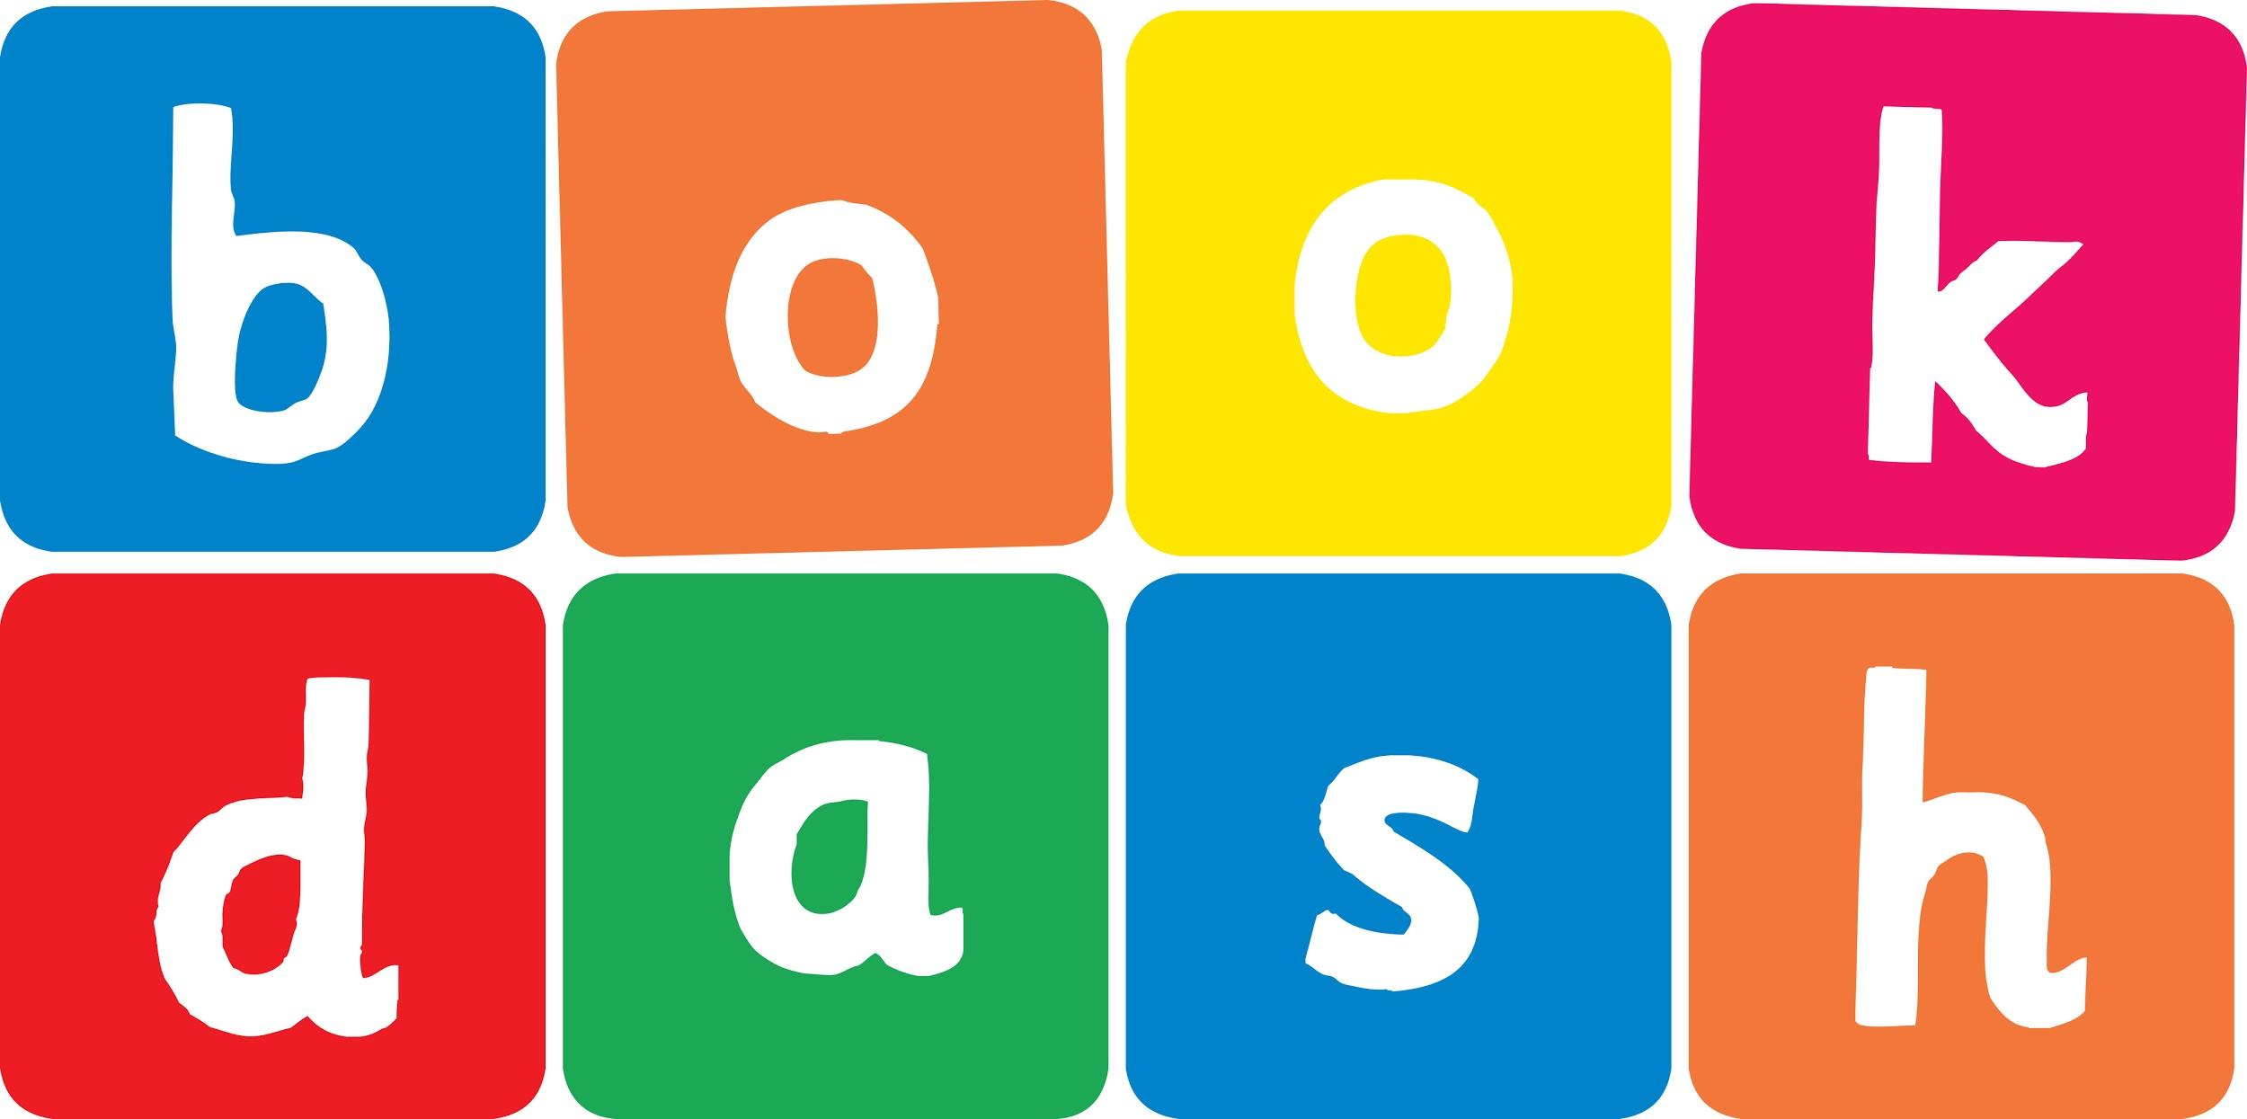
Book Dash Translation Template

Instructions
- If no text appears on a page, please indicate this in the cell with “N/A”
- Please save this file using the format: english-title_language.doc. For example: singing-the-truth_isixhosa.doc

Book Title in English: | Egg
Language of Translation: | IsiZulu
Translated Title: | Iqanda
Translator’s full name and/or organisation: | Nonkululeko Nhlapo

Page | English | Translation
Cover | Egg | Iqanda
Inside front cover | No text | NA
Book-plate page. | Egg  This book belongs to: | Iqanda  Le ncwadi ngeka:
Endpapers. | No text | NA
Endpapers. | No text | NA
Copyright page. No need to translate. | No translation | NA
Title page.
1 (leave blank if no text)
2
3
4
5 | Egg | Iqanda
6
7 | My egg? | Ngabe iqanda lami?
8
9 | Not my egg | Akulona iqanda lami
10
11 | My egg? | Ngabe iqanda lami?
12
13 | Not my egg | Akulona iqanda lami
14
15 | My egg? | Ngabe iqanda lami?
16
17 | Not my egg | Akulona iqanda lami
18
19 | My egg? | Ngabe iqanda lami?
20
21 | Not my egg | Akulona iqanda lami
22
23
24 | My egg? | Ngabe iqanda lami?
25
26 | Our egg | Iqanda lethu
27
28
29
30
Endpapers. | No text | NA
Endpapers. | No text | NA
Blank or decoration. | No translation unless there is text
Inside back cover. | No text | NA
Back cover

