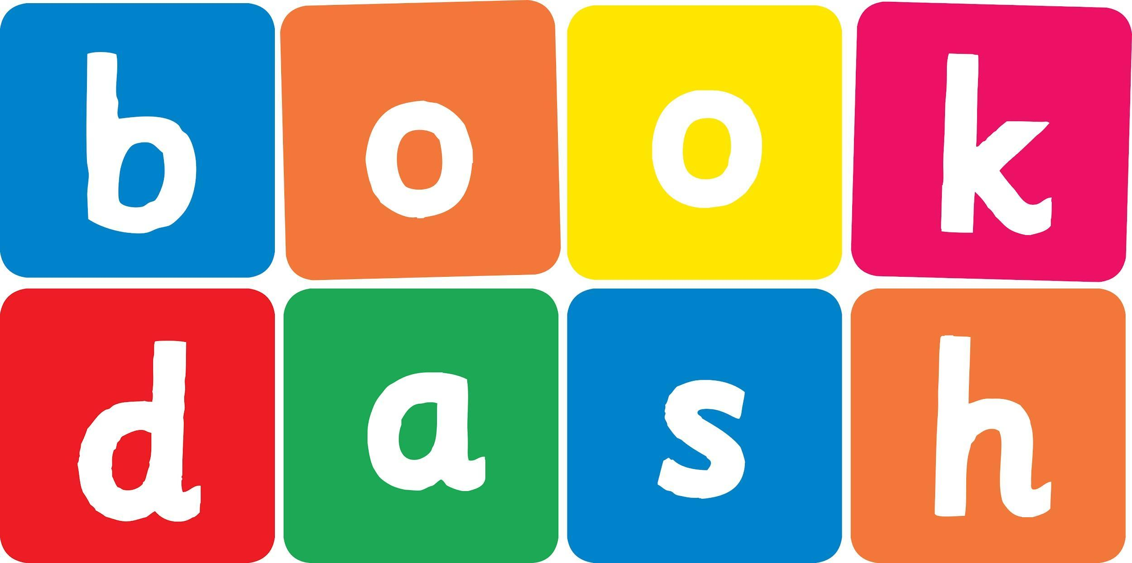
Book Dash Story Draft

Story Title Idea: | Let’s Be Friends!
Book Dash location: | Cape Town
Blurb
Imprint page | Let's Be Friends  Illustrated by Emma Bosman  Written by Murray Hunter  Designed by Wilna Combrinck  Edited by Ester Levinrad
Note: You can either write the story as it comes to you, or divide it up into spreads: You have 12 double-page spreads to use and remember, keep it to one idea/action/illustration per spread!
Spread 1 | [Image: We’re deep in the ocean, in a domestic scene: The Shark ‘stands’ in the middle of its living room. Perhaps in the corner is a calendar with an upcoming date circled]  It’s time to make some friends!
Spread 2 | [Image: the shark, self-consciously looking into the mirror]  Making friends can be hard. But let’s try!
Spread 3 | [Image: The shark, prowling the depths, sees a seal swimming about]  Hello! Hi! Do you like to swim? So do I!
Spread 4 | [Image: The shark looms hopefully  LET’S BE FRIENDS!  The seal, seeing only a comically fearsome snaggled-toothed shark in rapid approach,
Spread 5 | flees in terror]  Oh dear.
Spread 6 | [Image: The shark, once again on the prowl, spies an octopus hunting in the kelp]  Hello! Hi! What are we looking for? I can help.  LET’S BE FRIENDS!
Spread 7 | [Image: Once again, the octopus sees only a brutish apex predator bearing down with jaws a-gnashing, and makes a quick escape]  Oh my.
Spread 8 | [Image: Now, the shark sees a diver scuba-ing about]  Hello! Hi! Are you a fish?  LET’S BE FRIENDS!  [Image: The surfer does exactly what you’d expect: An undignified retreat]  Oh NO.
Spread 9 | [Image: Now we’re back in the shark’s den. It’s all alone, with a sad little party hat, and a beautiful cake and crockery placed upon an empty table.]  NOBODY WANTS TO BE MY FRIEND.
Spread 10 | [Image: But then! … a knock at the door… it’s….]  [Image: …a lion fish! And then… a blob fish!]
Spread 11 | [Image: A sea anemone! An angler fish! The snaggled-toothed shark beams with joy as all the hideous unloved creatures of the sea stream in]
Spread 12 | [Image: They all gather around with cake and hats and cups and together they say, in all their unashamed grotesqueness…]  LET’S BE FRIENDS!

