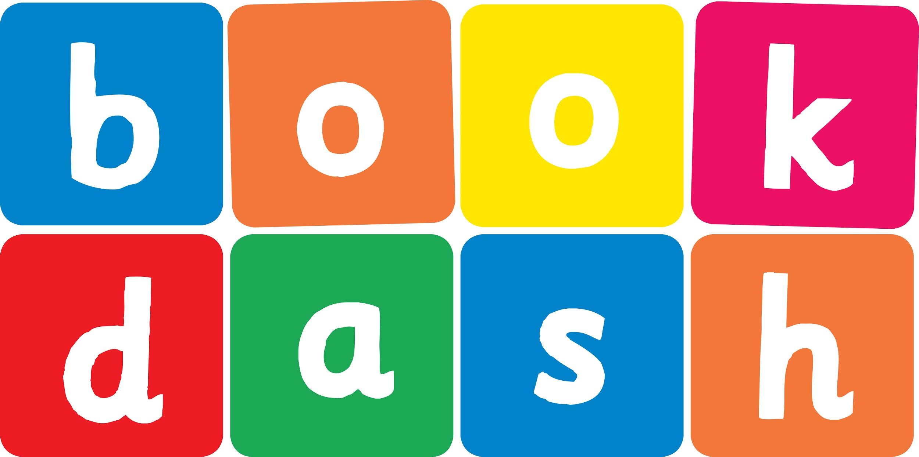
Book Dash Translation Template

Instructions
- If no text appears on a page, please indicate this in the cell with “N/A”
- Please save this file using the format: english-title_language.doc. For example: singing-the-truth_isixhosa.doc

Book Title in English: | My Special Blankie
Language of Translation: | IsiXhosa
Translated Title: | Ingubo Yam eKhethekileyo
Translator’s full name and/or organisation: | Sihle Siko

Page | English | Translation
Cover | My Special Blankie | Ingubo Yam eKhethekileyo
Inside front cover | No text | NA
Book-plate page. | My Special Blankie  This book belongs to | Ingubo Yam eKhethekileyo  Le ncwadi yeka
Endpapers. | No text | NA
Endpapers. | No text | NA
Copyright page. No need to translate. | No translation | NA
Title page. | My Special Blankie | Ingubo Yam eKhethekileyo
5
6 | Can you see me?  I am on my Mama’s back in my special blankie. | Uyandibona?  Ndisemqolo kuMama wam engubeni yam ekhethekileyo.
7
8 | I love Mama.  And Mama loves me. | Ndiyamthanda uMama.  NoMama uyandithanda.
9 | And I love, love, LOVE my special blankie. | Yaye ndiyayithanda, ndiyayithanda, NDIYAYITHANDA ingubo yam ekhethekileyo.
10 | Boom  I like to make noise. | Gqum-m-m Ndiyakuthanda ukwenza ingxolo.
11 | Bang!  Bash! | Mba-a-a!  Xhafa-a!
12 | But Mama likes it quiet. | Kodwa uMama uthanda kuthuleke.
13 | Shhh  Shhh  Shhh | Shhh  Shhh  Shhh
14 | Mama does her work. | UMama wenza umsebenzi wakhe.
15 | Go!  Go!  Go! | Hamba!  Hamba!  Hamba!
16 | Woah! | Wha-a-a!
17 | And I like to play.  Woah!  Woah! | Ndaye ndiyakuthanda ukudlala.  Wha-a-a!  Wha-a-a!
18 | Oh, I love, love, LOVE my special blankie. | Owu, ndiyayithanda, ndiyayithanda, NDIYAYITHANDA ingubo yam ekhethekileyo.
19
20 | But when I eat, Mama says my special blankie must watch. | Kodwa xa ndisitya, uMama uthi ingubo yam ekhethekileyo mayibukele.
21
22
23 | And when I wash, my special blankie must wait where it is dry. | Ndaye xa ndihlamba, ingubo yam ekhethekileyo mayilinde apho komileyo.
24
25 | I love bedtime stories with Mama.  My special blankie listens with me… | Ndiyawathanda amabali exesha lokulala noMama.  Ingubo yam ekhethekileyo imamela nam…
26 | …and helps me to go to sleep. | …ize indincede ukundilalisa.
27
28 | I love, love, LOVE my special blankie. | Ndiyayithanda, ndiyayithanda, NDIYAYITHANDA ingubo yam ekhethekileyo.
29
30
31
32
Endpapers. | No text | NA
Endpapers. | No text | NA
Blank or decoration. | No translation unless there is text
Inside back cover. | No text | NA
Back cover | Lerato’s world is made extra special by Mama and a colourful blankie.  What is your special thing? | Ilizwe likaLerato lenziwe lakhetheka ngakumbi nguMama nengubo emibalabala.  Unantoni wena ekhethekileyo?

