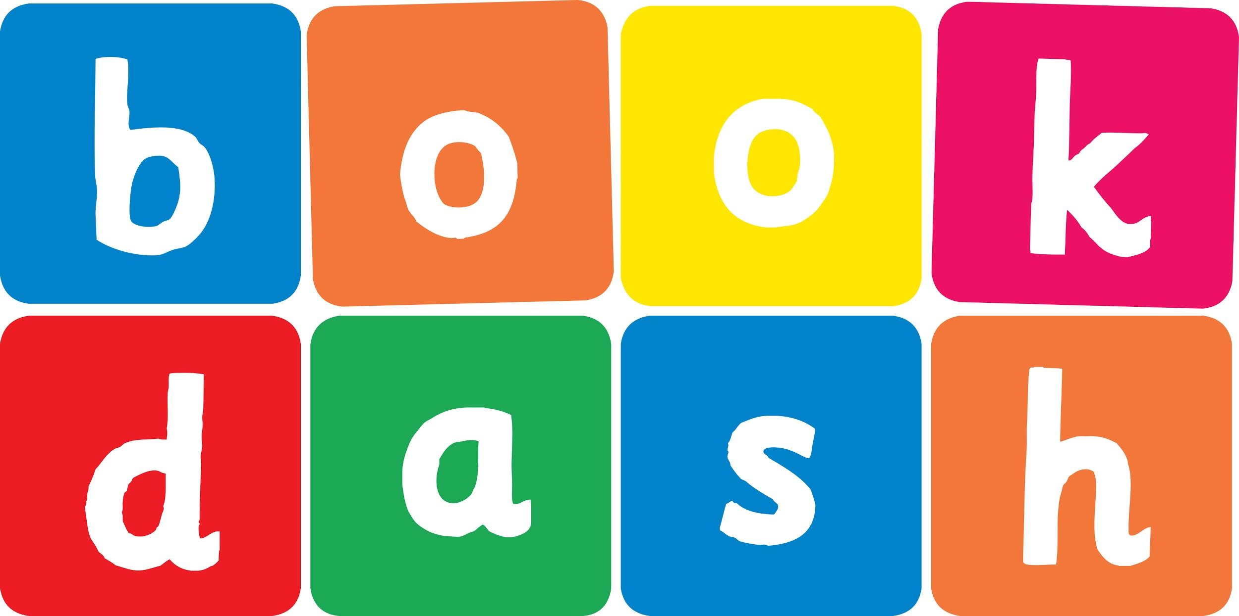
Book Dash Translation Template

Instructions
- If no text appears on a page, please indicate this in the cell with “N/A”
- Please save this file using the format: english-title_language.doc. For example: singing-the-truth_isixhosa.doc

Book Title in English: | MY SPECIAL HAIR
Language of Translation: | IsiZulu
Translated Title: | IZINWELE ZAMI EZIKHETHEKILE
Translator’s full name and/or organisation: | Nonkululeko Nhlapo

Page | English | Translation
Cover | MY SPECIAL HAIR | IZINWELE ZAMI EZIKHETHEKILE
Inside front cover | No text | NA
Book-plate page. | MY SPECIAL HAIR  This book belongs to | IZINWELE ZAMI EZIKHETHEKILE  Le ncwadi ngeka
Endpapers. | No text | NA
Endpapers. | No text | NA
Copyright page. No need to translate. | No translation | NA
Title page. | MY SPECIAL HAIR | IZINWELE ZAMI EZIKHETHEKILE
5
6 | I have a very special head, a special head of hair. My special hair is quite unique. My special hair is rare. | Nginekhanda elikhetheke kakhulu, ikhanda lezinwele ezikhethekile. Izinwele zami ezikhethekile zihlukile. Izinwele zami ezikhethekile azijwayelekile.
]

8 | It grows not just on any head, but mine, my own, just me! My special hair does special things – it’s magic hair, you see. | Ziyakhula kodwa hhayi kunoma yiliphi ikhanda, kwelami, elami ngedwa!  Izinwele zami ezikhethekile zenza izinto ezikhethekile – izinwele ezinomlingo, uyabona.
9
10
11 | In summer when the sun is hot, with no shade anywhere, I do not sweat, I do not burn. I grow a hat of hair. | Ehlobo lapho ilanga lishisa, lingekho ithunzi, angijuluki, futhi angishi. Ngizenzela isigqoko ngezinwele.
12
13 | In winter when my nose turns red, and when the cold wind blows, my special hair grows very long. I’m wrapped from top to toes. | Ebusika lapho amakhala ami ejika eba bomvu futhi uma kuvunguza umoya obandayo, izinwele zami ezikhethekile zikhula zibe zinde kakhulu. Ngizigoqa ngazo kusukela phezulu kuya phansi ezinzwaneni.
14 | In spring when all the birds come out, and each one builds a nest, my head is full of songs because my special hair is best. | Entwasahlobo lapho izinyoni ziphuma futhi zizakhela izidleke, ikhanda lami lisuke ligcwele izingoma ngoba izinwele zami ezikhethekile zingungqa phambili.
15
16 | In autumn when the leaves fall down, no flowers to be found, my special head begins to bloom bright blossoms all around. | Ekwindla lapho amacembe ewa ezihlahleni zingekho nezimbali, ikhanda lami elikhethekile liyaqhakaza yonke indawo.
17
18
19 | My special hair is stiff and strong. It does not hang or drape. I never look the same because my hair can change its shape. | Izinwele zami ezikhethekile ziqinile. Azilengi. Angibukeki ngendlela eyodwa ngoba izinwele zami ziyakwazi ukushintsha isimiso sazo.
20
21 | My special hair is full of curls.  It’s twisted,  tangled,  tough.  My special hair grows hairy hands – a place to store my stuff. | Izinwele zami ezikhethekile zigoqene. Zisontekile,  zihlangene,  ziqinile.  Izinwele zami ezikhethekile zikhula zibe nezandla – nokuyindawo engibeka kuyo izinto zami.
22 | My special hair grows special wings – so smooth, so soft, so light. They float around my face, until my hair and I take flight. | Izinwele zami ezikhethekile zinamaphiko akhethekile – zintofontofo, zithambile futhi zilula. Zilenga kahle ebusweni bami, ngize ngindize nazo.
23
24
25 | My special hair is colourful, a rainbow all in one! It brightens up the darkest day. My hair is full of fun. | Izinwele zami ezikhethekile zimibalabala, ziwuthingo lwenkosazane! Ziqhakazisa ngisho nosuku olumnyama. Izinwele zami ziyathokozisa.
26 | My special hair is full of love. With love my head is crowned. It grows and grows and grows until I spread it all around. | Izinwele zami ezikhethekile zinothando. Ngothando ikhanda lami lithwele umqhele. Ziyakhula, zikhule, zikhule zize zigcwale yonke indawo.
27
28 | So many types of special heads, so many types of hair. Be proud of what you have on top, your magic grows up there! | Ziningi izinhlobo zamakhanda akhethekile, ziningi izinhlobo zezinwele ezikhethekile. Ziqhenye ngonakho phezulu, umlingo wokho ukhulela khona!
29
30
Endpapers. | No text | NA
Endpapers. | No text | NA
Blank or decoration. | No translation unless there is text
Inside back cover. | No text | NA
Back cover | A story about my special hair. How special it can be! So many types of special hair – just look around, you’ll see. | Indaba emayelana nezinwele zami ezikhethekile. Indlela ezikhetheke ngayo! Ziningi izinhlobo zezinwele ezikhethekile – buka yonke indawo, uzobona.

