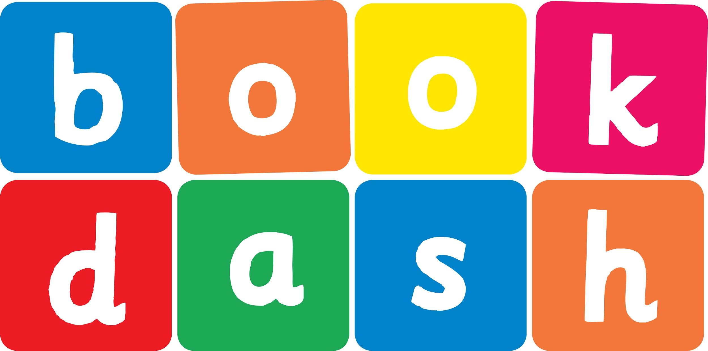
Book Dash Translation Template

Instructions
- If no text appears on a page, please indicate this in the cell with “N/A”
- Please save this file using the format: english-title_language.doc. For example: singing-the-truth_isixhosa.doc

Book Title in English: | Scared Tumi
Language of Translation: | IsiZulu
Translated Title: | UTumi Osabayo
Translator’s full name and/or organisation: | Nonkululeko Nhlapo

Page | English | Translation
Cover | Scared Tumi | UTumi Osabayo
Inside front cover | No text | NA
Book-plate page. | Scared Tumi  This book belongs to | UTumi Osabayo  Le ncwadi ngeka
Endpapers. | No text | NA
Endpapers. | No text | NA
Copyright page. No need to translate. | No translation | NA
Title page. | Scared Tumi | UTumi Osabayo
5
6 | My name is Tumi and I am scared. | Igama lami nginguTumi futhi ngiyasaba.
7
8 | Mama says it’s okay to be scared. “Everybody gets scared.” | UMama uthi kulungile ukwesaba. “Wonke umuntu unokwesaba.”
9
10 | What if there is a monster under my bed? | Kungathiwani uma kukhona inunu ngaphansi kombhede wami?
11
12 | “Then I will tell it to go away and NEVER come back.” | “Ngingasitshela ukuthi sihambe futhi SINGAPHINDE sibuye.”
13
14 | What if there are eyes in the bath tub drain? | Kungathiwani uma kunamehlo endaweni yokukhipha amanzi kabhavu wokugezela?
15
16 | “Then your big sister, Kamo, will pull you out of the bath.” | “Udadewenu omdala, uKamo, uzokukhipha kubhavu wokugezela.”
17
18 | What if a whale swallows me at the beach? | Kungathiwani uma umkhoma ungigwinya olwandle?
19
20
21 | “Then Kamo and I will swim into the whale’s mouth to rescue you.” | “Mina noKamo sizobhukuda singene emlonyeni womkhoma sikuhlenge.”
22 | What if I can’t sing ABC and the other kids laugh at me? | Kungathiwani uma ngingakwazi ukucula u-ABC bese ngihlekwa ezinye izingane?
23
24 | “Then Teacher Jill will help you remember.” | “UThisha uJill uzokusiza ukuthi ukhumbule.”
25
26 | What if I’m scared of going to the dentist tomorrow? | Kungathiwani uma ngisaba ukuya kudokotela wamazinyo kusasa?
27
28 | “I will be right there holding your hand.”  Everybody gets scared. Mama says it’s okay. | “Ngizobe ngikhona ngikubambe ngesandla.”  Wonke umuntu unokwesaba. UMama uthi kulungile lokho.
29
30
31
32
Endpapers. | No text | NA
Endpapers. | No text | NA
Blank or decoration. | No translation unless there is text | N/A
Inside back cover. | No text | NA
Back cover | “What if there’s a monster under my bed?”  Tumi is scared. Mama tries to show him that everything is okay. | “Kungathiwani uma kukhona inunu ngaphansi kombhede wami?”  UTumi uyesaba. UMama uzama ukumbonisa ukuthi konke kuhamba kahle.

