A/w refs:
Note: storkboxes are moveable info, for best design practice
Here is a nice boy.

[book plate]
[endpapers]
[imprint page: verso]
[title page: recto]

1. Story spread 1
verso (L): Granny plus little girl, reading this book
recto (R): Text: How to use this book

2. Story spread 2
verso (L): Text: Humans are mammals
recto (R): cat, dog, camel, elephant
+ storkbox
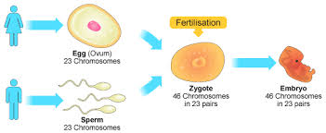
3. Story spread 3
verso (L): Small girl to big girl progress

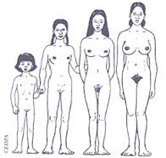
recto (R): Small boy to big boy progress
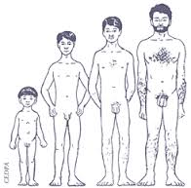

4. Story spread 4
verso (L): Fallopian tubes; menstruation
+ storkbox – periods are normal
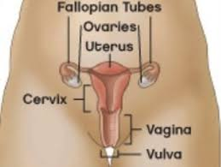
recto (R):

5. Story spread 5
verso (L): Hormones etc. A/w: kissing
+ storkbox – consent

recto (R):

6. Story spread 6
verso (L): vanilla/missionary sex
+ storkbox – erection and condom
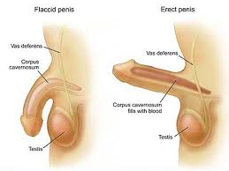
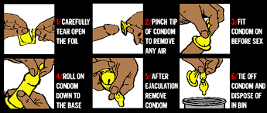
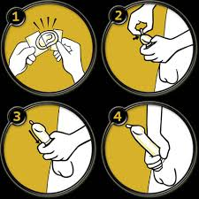
recto (R):
+ storkbox – sensations
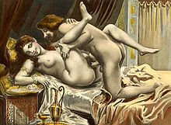


7. Story spread 7
verso (L): sperm location
+ storkbox – twins
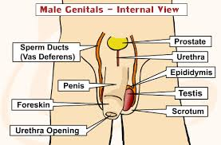
recto (R): Sperm heading towards egg.
+ storkbox – thigh sex counts
8. Story spread 8
verso (L): + storkbox – x+ y
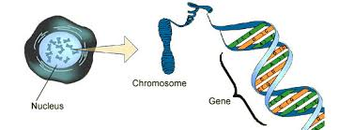
recto (R): helix?
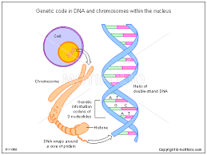

9. Story spread 9
verso (L): baby in utero; focus on umbilical cord
+ storkbox – no periods while pregnant
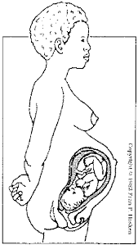
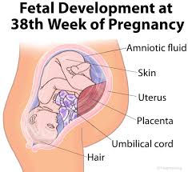
recto (R): + storkbox – babies cough, sneeze, yawn in utero
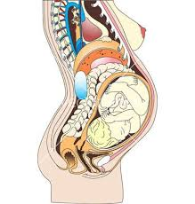
10. Story spread 10
verso (L): labour/crowning
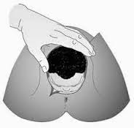
+ storkbox – caesarean section
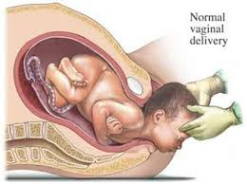
recto (R): snipping the cord

11. Story spread 11
verso (L): neonate/man holding baby to support its neck


recto (R): + storkbox – eye colour

12. Story spread 12
verso (L): Bad sex; numbers
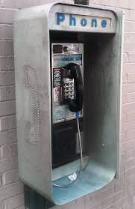

recto (R): Glossary? Here or as endpages? Dps and storkFEST
[endpapers]

