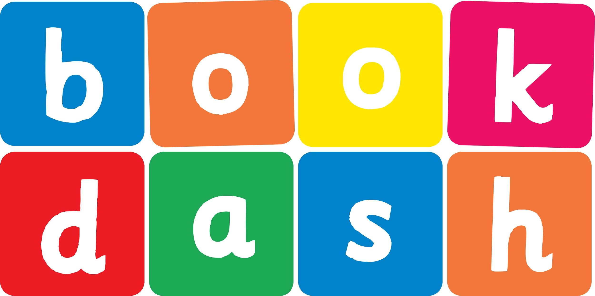
Book Dash Translation Template

Instructions
- If no text appears on a page, please indicate this in the cell with “N/A”
- Please save this file using the format: english-title_language.doc. For example: singing-the-truth_isixhosa.doc

Book Title in English: | The best thing ever
Language of Translation: | isiXhosa
Translated Title: | Eyona nto inomfaneleko
Translator’s full name and/or organisation: | Nal’ibali

[Inside front cover]  This book belongs to | Umnikazi wale ncwadi ngu
[Copyright page. No need to translate.] | [Copyright page. No need to translate.]
[Title page. Please translate title.] | Eyona nto inomfaneleko
[Endpapers. No translation] | [Endpapers. No translation]
No text | UMuzi uyakuthanda ukwakha izinto. Uphupha esakha eyona nto inomfaneleko kakhulu.
Ngenye imini wakha ikhu he zokudlalisa. | Kodwa lalingeyonto iyeyona inomfaneleko.
Izolo wakhele izilwanyana zakhe ibhlorho. Yona ibilungile, kodwa ingeyonto iyeyona inomfaneleko. | Namhlanje uMuzi uza kutyelela uMakhulu. Ulusizi. Ngaphandle kwezinto zakhe zokudlala, angayakha njani eyona nto iyeyona inomfaneleko?
No text | Kwisitophu seebhasi, uMuzi uye wamangaliswa. Ubona izinto ezibomvu nezizuba. Izinto ezincinane nezinto ezinkulu. Izinto ezintsha nezinto ezindala.
No text | UMuzi unengcingane entsha yokwakha eyona nto inomfaneleko kakhulu.
Endleleni eya kwaMakhulu, uMuzi ufumana izinto ezininzi. Izinto ezinde nezinto ezimfutshane. Izinto ezingqukuva nezinto ezisisikwere. | No text
No text | Ngasemlanjeni, uMuzi ufumana nezinye izinto ezininzi. Izinto ezithambileyo nezinto ezitsolo. Izinto eziluhlaza nezinto ezintsundu.
“Jonga, Muzi! Sesilapha.”  Lo gama uMakhulu esabhakela abahambi abalambileyo, uMuzi yena uyakha. | “Jonga, Makhulu, indlu yakho entsha.”  “Owu, Muzi,” uyahleka uMakhulu. “Le yeyona nto inomfaneleko!”
“Makhulu, Makhulu!” watsho uMuzi.
“Ihlabathi lizele zizinto zokudlalisa. Jonga into endinokuyakha.”
[Endpapers. No translation] | [Endpapers. No translation]
[Blank or decoration. No translation unless there is text] | [Inside back cover. No translation]

Back cover blurb (find this on the print-ready file, cover):
UMuzi uyakuthanda ukwakha izinto. Uphupha esakha eyona nto inomfaneleko kakhulu…

