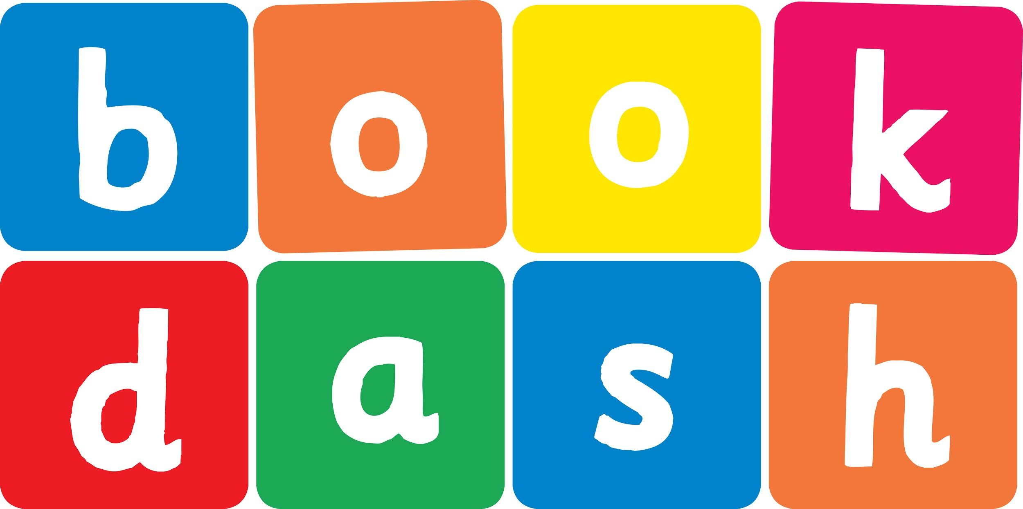
Book Dash Translation Template

Instructions
- If no text appears on a page, please indicate this in the cell with “N/A”
- Please save this file using the format: english-title_language.doc. For example: singing-the-truth_isixhosa.doc

Book Title in English: | The Great Tidy Up
Language of Translation: | IsiXhosa
Translated Title: | Ukucoca Okukhulu
Translator’s full name and/or organisation: | Sihle Siko

Page | English | Translation
Cover | Title The Great Tidy Up | Ukucoca Okukhulu
Inside front cover | No text | NA
Book-plate page. | Title The Great Tidy Up  This book belongs to | Ukucoca Okukhulu  Le ncwadi yeka
Endpapers. | No text | NA
Endpapers. | No text | NA
Copyright page. No need to translate. | No translation | NA
Title page. | Title The Great Tidy Up | Ukucoca Okukhulu
1 (leave blank if no text)
2
3
4
5
6 | ‘We are going to have so much fun while Gogo is having a nap,’ says big sister Khwezi.  ‘Ooh yes!’ says little brother Mzamo.  ‘What we will do?’ | ‘Siza konwaba kakhulu ngeli xesha uMakhulu aleleyo,’ utsho uKhwezi usisi omdala.  ‘Ewe kunjalo!” utsho umninawa uMzamo.  ‘Siza kwenza ntoni?’
7
8 | ‘We will clean the house for Papa and Mama while they are out.’  ‘That’s no fun ,’ says Mzamo.  ‘Uh uh, no.  Not me.  I don’t want to clean up!’ | ‘Siza kucocela uTata noMama indlu ngeli xesha basaphumileyo.’  ‘ Ayilolonwabo olo,’ utsho uMzamo.  ‘Yho yho, hayi.  Hayi mna.  Andifuni kucoca!’
9
10 | ‘But Mama and Papa will be so proud.’  ‘Let me show you how much fun we will have!’ says Khwezi. | ‘Kodwa uMama noTata baya kuzingca.’  ‘Mandikubonise ukuba siza konwaba kangakanani!’ utsho uKhwezi.
11
12 | ‘First we will put the toys away!’ | ‘Okokuqala siza kuqoqosha iithoyi sizisuse!’
13
14 | ‘Now we will sweep the stoep!’ | ‘Ngoku siza kutshayela isituphu!’
15
16
17 | ‘Now we will wash dishes!’ | ‘Ngoku siza kuhlamba izitya!’
18 | ‘Now we will wash the windows!’ | ‘Ngoku siza kuhlamba iifestile!’
19
20 | ‘Now we will polish the floor!’ | ‘Ngoku siza kupolisha phantsi!’
21
22 | ‘Now we will wash the clothes!’ | ‘Ngoku siza kuhlamba iimpahla!’
23
24 | ‘Now we will hang the clothes up!’ | ‘Ngoku siza koneka iimpahla!’
25
26 | ‘SURPRISE!’ | ‘Tharaaa!’
27
28 | ‘I have been watching them the whole time and they have been little angels!’ says Gogo. | ‘Bendibabukele lonke ixesha kwaye bebeziingelosi ezincinci!’ utsho uMakhulu.
29
30
31
32
Endpapers. | No text | NA
Endpapers. | No text | NA
Blank or decoration. | No translation unless there is text
Inside back cover. | No text | NA
Back cover | When Gogo takes a nap,  Khwezi and Mzamo decide to tidy up.  What could possibly go wrong? | Xa uMakhulu engqengqa, uKhwezi noMzamo bagqiba kwelokuba bacoce.  Yintoni engaze ingahambi kakuhle?

