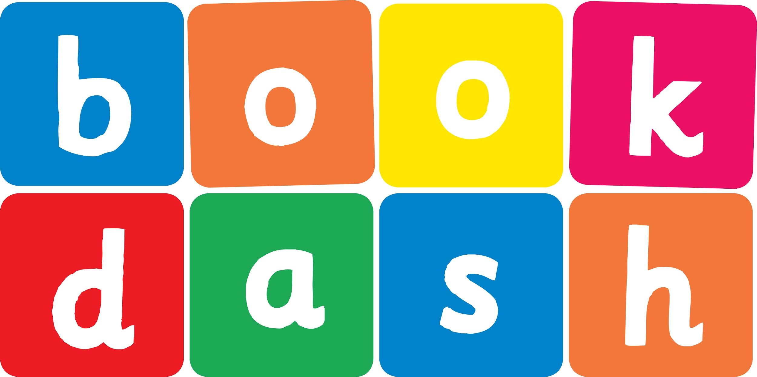
Book Dash Translation Template

Instructions
- If no text appears on a page, please indicate this in the cell with “N/A”
- Please save this file using the format: english-title_language.doc. For example: singing-the-truth_isixhosa.doc

Book Title in English: | The Great tidy Up
Language of Translation: | IsiZulu
Translated Title: | Ukulungisa Okuhle
Translator’s full name and/or organisation: | Nonkululeko Nhlapo

Page | English | Translation
Cover | The Great tidy Up | Ukulungisa Okuhle
Inside front cover | No text | NA
Book-plate page. | The Great tidy Up  This book belongs to | Ukulungisa Okuhle  Le ncwadi ngeka
Endpapers. | No text | NA
Endpapers. | No text | NA
Copyright page. No need to translate. | No translation | NA
Title page. | The Great tidy Up | Ukulungisa Okuhle
1 (leave blank if no text)
2
3
4
5
6 | ‘We are going to have so much fun  while Gogo is having a nap,’ says big sister Khwezi.  ‘Ooh yes!’ says little brother Mzamo.  ‘What will we do?’ | 'Sizozithokozisa kakhulu ngenkathi uGogo ecambalele, 'kusho udadewetthu omdala uKhwezi. 'Yebo kunjalo!' kusho umfowethu omncane uMzamo.  ‘Sizokwenzenjani?'
7
8 | ‘We will clean the house for Papa  and Mama while they are out.’  ‘That’s no fun,’ says Mzamo.  ‘Uh uh, no.  Not me.  I don’t want to clean up!’ | 'Sizohlanza indlu ngenkathi uBaba noMama besaphumile.'  'Akumnandi lokho,' kusho uMzamo.  'Hhayi hhayi, cha. Hhayi mina.  Angifuni ukuhlanza indlu!'
9
10 | ‘But Papa and Mama will be so proud. Let me show you how much fun we will have!’ says Khwezi. | ‘Kepha uBaba noMama bazoziqhenya ngathi. Woza ngikubonise ukuthi sizozithokozisa kangakanani!’ kusho uKhwezi.
11
12 | ‘First we will put the toys away!’ | ‘Sizoqala ngokubeka kahle amathoyizi!’
13
14 | ‘Now we will sweep the stoep!’ | ‘Manje sizoshanela isitubhu!’
15
16
17 | ‘Now we will wash the dishes!’ | ‘Manje sizogeza izitsha!’
18 | ‘Now we will  wash the windows!’ | ‘Manje sizogeza amawindi!’
19
20 | ‘Now we will polish the floor!’ | ‘Manje sizopholisha phansi!’
21
22 | ‘Now we will wash the clothes!’ | ‘Manje sizowasha izimpahla!’
23
24 | ‘Now we will hang the clothes up!’ | ‘Manje sizoneka izimpahla!’
25
26 | “SURPRISE!” | “ISIMANGA!”
27
28 | ‘I have been watching them the whole time and they have been little angels!’ says Gogo. | ‘Bengibagadile sonke isikhathi futhi bebeyizingelosi ezincane!’ kusho uGogo
29
30
Endpapers. | No text | NA
Endpapers. | No text | NA
Blank or decoration. | No translation unless there is text
Inside back cover. | No text | NA
Back cover | When Gogo takes a nap, Khwezi and Mzamo decide to tidy up. What could possibly go wrong? | Ngesikhathi uGogo ecambalala, uKhwezi noMzamo bathatha isinqumo sokulungisa kahle. Yini ezongahambi kahle?

