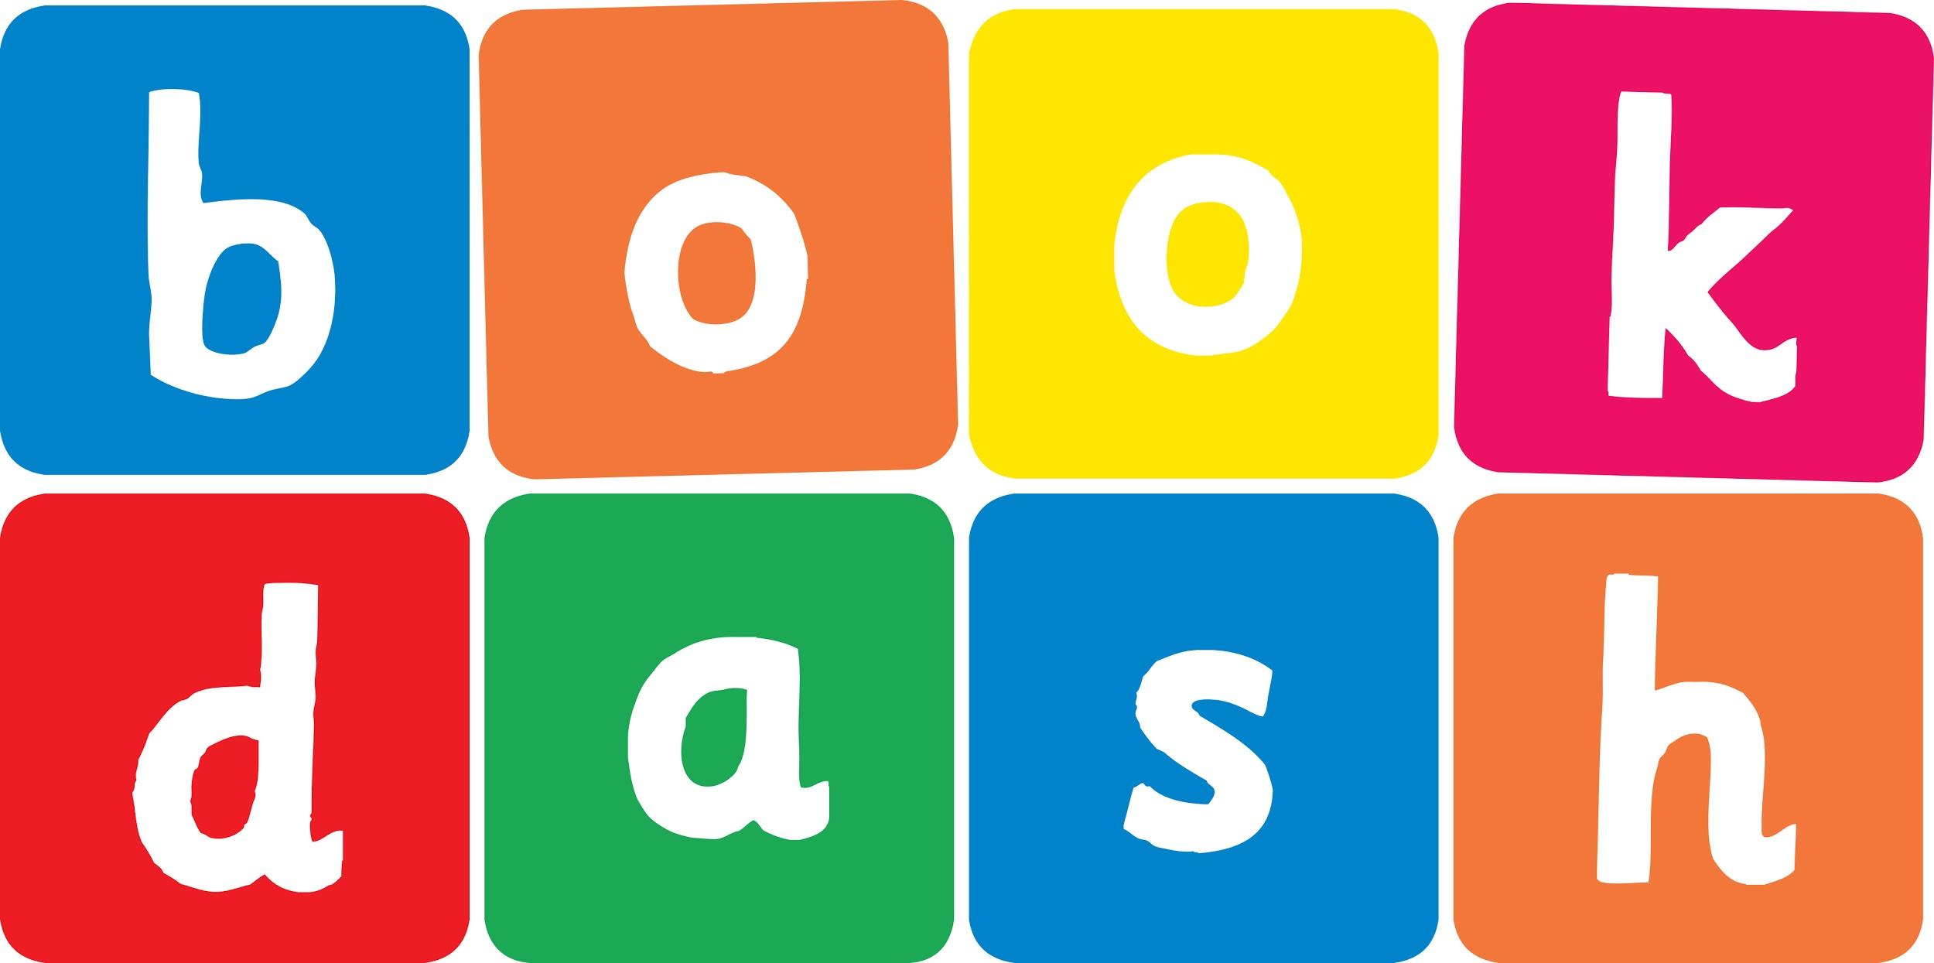
Book Dash Translation Template

Instructions
- If no text appears on a page, please indicate this in the cell with “N/A”
- Please save this file using the format: english-title_language.doc. For example: singing-the-truth_isixhosa.doc

Book Title in English: | The things that really matter
Language of Translation: | IsiXhosa
Translated Title: | Ezona zinto zibalulekileyo
Translator’s full name and/or organisation: | Sihle Siko

Page | English | Translation
Cover | The things that matter | Ezona zinto zibalulekileyo
Inside front cover | No text | NA
Book-plate page. | The things that matter  This book belongs to: | Ezona zinto zibalulekileyo  Le ncwadi yeka:
Endpapers. | No text | NA
Endpapers. | No text | NA
Copyright page. No need to translate. | No translation | NA
Title page. | The things that matter | Ezona zinto zibalulekileyo
1 (leave blank if no text) | We are going on a trip.  I ask Mama what to pack.  She says, ‘the things that really matter.’ | Sithatha uhambo.  Ndibuza uMama ukuba ndipakishe ntoni.  ‘Ezona zinto zibalulekileyo,’ utsho.
2 | We stop at the windmill for breakfast, the jungle gym is so much fun. | Simisa eWindmill ukuze sitye isidlo sakusasa, umtyibilizi uyonwabisa kakhulu.
3 | I forget my toy. | Ndilibala ithoyi yam.
4 | I am sad in the car, but Tando is happy.  ‘Horray! Now you can play with me!’ he says. | Ndikhathazekile emotweni, kodwa uTando wonwabile.  ‘He-kee!’Ngoku ungadlala nam!’ utsho.
5 | We stop at a farm to see some animals.  Tando is searching so hard for a springbok. | Simisa efama ukuze sibone izilwanyana.  UTando ukhangela kakhulu ukubona imbabala.
6 | A monkey gets away with his headphones. | Inkawu ibaleka nezinto zakhe zokumamela zasezindlebeni.
7 | He is sad in the car, but I am happy.  ‘Horray! Now you can sing with me!’ I say. | Ukhathazekile emotweni, kodwa mna ndonwabile.  ‘He-kee!’Ngoku ungacula nam!’ nditsho.
8 | We stop at a roaring waterfall.  We are so excited, we are pushing and pulling. | Simisa kwiingxangxasi ezigqumayo.  Sonwabe kakhulu, siyatyhalana size sitsalane.
9 | Papa falls in the water, and so does his map. | UTata utshona emanzini, kanjalo nemephu yakhe.
10 | Papa is sad in the car, but Mama is happy.  ‘Horray! Now I can help you find our way!’ she says . | UTata ukhathazekile emotweni, kodwa uMama wonwbile.  ‘He-kee!’ Ngoku ndingakuncedisa sifumane indlela yethu!’ utsho.
11 | We stop at the roadside vendor to buy some mielies. | Simisa kumntu othengisa ecaleni kwendlela ukuze sithenge umbona.
12 | Mama bends over to pick the best ones, and her glasses fall and break. | UMama uyagoba ukukhetha owona umnandi, zize izispeksi zakhe ziwe zophuke.
13 | Mama is sad in the car, but Papa is happy.  ‘Horray! Now I can help you find our way together!’ Papa says. | UMama ukhathazekile emotweni, kodwa uTata wonwabile.  ‘He-kee!’Ngoku ndingakunceda sifumane indlela yethu kunye!’ utsho uTata.
14 | We stop at an ancient hill to get the view of the valley. Papa is making silly jokes for us to smile for the picture, | Simisa kwinduli endala ukuze sikwazi ukubona intlambo. Utata uyasiqhula ukuze sincumele ifoto,
15 | but ... | kodwa …
16 | When we get back to the car, it won’t start.  Everyone stops laughing.  ‘Don’t worry ...’ says Mama.  ‘We can still have a good time.  We are the things that really matter.’ | Xa sibuyela emotweni, ayifuni kuduma.  Wonke umntu uyayeka ukuhleka.  ‘Ningakhathazeki …’ utsho uMama.  ‘Sisenganexesha elimnandi.  Sithi ezona zinto zibalulekileyo.’
17 | And so, we have a good time.  By playing and singing and finding our way together,  while we are enjoying our best mielies. | Ngoko ke, sinexesha elimnandi.  Ngokudlala nangokucula nangokufumana indlela kunye,  logama sonwabela owona mbona umnandi.
18
19
20
21
22
23
24
Endpapers. | No text | NA
Endpapers. | No text | NA
Blank or decoration. | No translation unless there is text
Inside back cover. | No text | NA
Back cover | What are the most important things to take with you on a trip?  Join Zuki, Tando, Mama and Papa on their eventful journey to find out. | Zintoni ezona zinto zibalulekileyo onokuziphatha xa uthatha uhambo?  Fumanisa ngokuthi uhambe kunye noZuki, uTando, uMama noTata kuhambo lwabo oluneziganeko.

