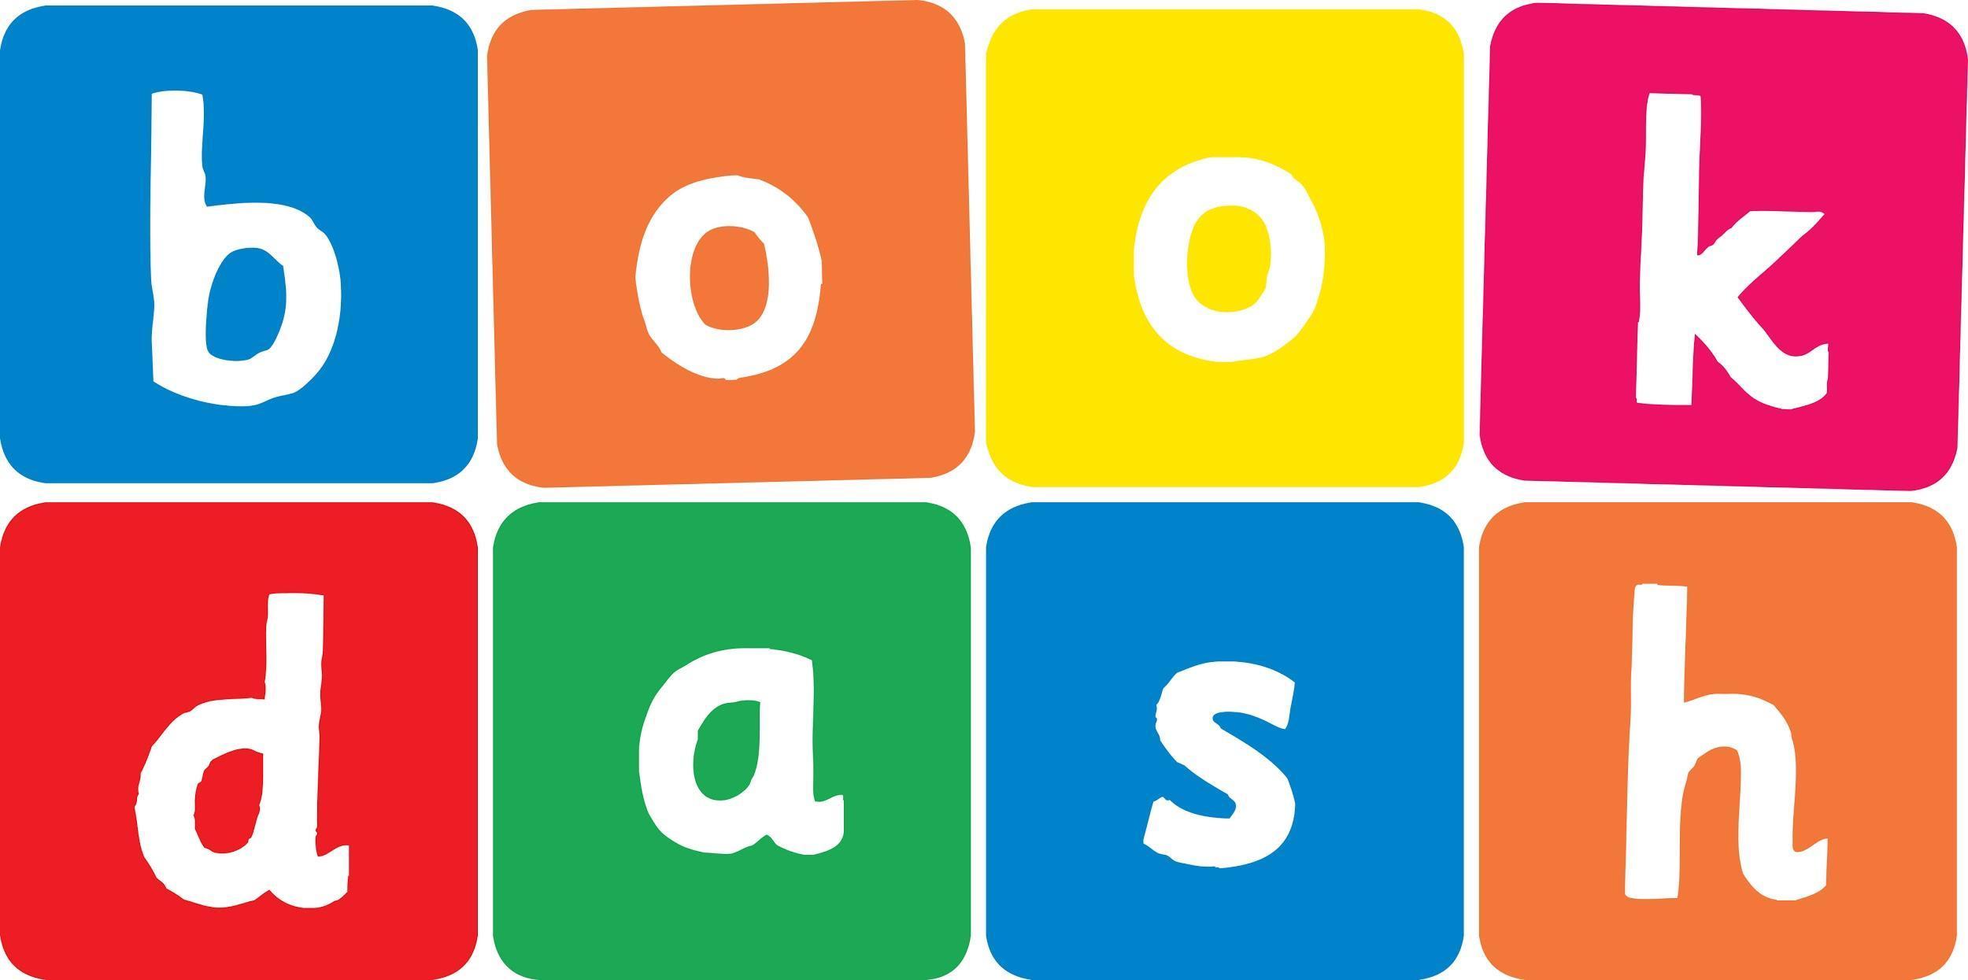
Book Dash Translation: Woof-Woof

Book Title in English: | Woof-Woof!
Language of Translation: | Swedish
Translated Title:

Page | English | Translation
Book plate page (P1) | This book belongs to
Imprint (P4) | Every child should own a hundred books by the age of five. To that end, Book Dash gathers creative professionals who volunteer to create new, African storybooks that anyone can freely translate and distribute. To find out more, and to download beautiful, print-ready books, visit bookdash.org.  Woof-woof!  Illustrated by Nicolene Louw  Written by Sindiwe Magona  Designed by Christelle Grobler  Edited by Glynis Lloyd  with the help of the Book Dash participants in Cape Town on 13 April 2019.  ISBN: 978-1-928497-34-9  This work is licensed under a Creative Commons Attribution 4.0 Licence (http://creativecommons.org/licenses/by/4.0/). You are free to share (copy and redistribute the material in any medium or format) and adapt (remix, transform, and build upon the material) this work for any purpose, even commercially. The licensor cannot revoke these freedoms as long as you follow the following license terms:  Attribution: You must give appropriate credit, provide a link to the license, and indicate if changes were made. You may do so in any reasonable manner, but not in any way that suggests the licensor endorses you or your use.  No additional restrictions: You may not apply legal terms or technological measures that legally restrict others from doing anything the license permits.  Notices: You do not have to comply with the license for elements of the material in the public domain or where your use is permitted by an applicable exception or limitation.  No warranties are given. The license may not give you all of the permissions necessary for your intended use. For example, other rights such as publicity, privacy, or moral rights may limit how you use the material.
Title (P5) | Woof-woof!
P7 | Daddy!
P9 | Don’t be scared.
P11 | Woof-woof out!
P12 | Look, Doggy’s bringing the ball.
P14 | Ball?
P16 | Doggy wants to play.  Play?
P18 | Catch the ball.
P21 | Woof-woof out!
P22 | Look, Daddy’s playing.
P25 | Now you play.
P27 | Catch, Woof-woof!
Back cover blurb | Doggy wants to play, but Baby is scared.

